**MCSA Project – Shimi Ben Giat**

**Table of Contents**

**1. Setting the lab 2**

**2.1 Promoting "DC" to Domain Controller 3**

**2.2 Creating 2 organizational units (OU) and groups 7**

**3.1 Configuring DHCP server 13**

**3.2 DHCP Scope 16**

**3.3 DHCP Exclusions 17**

**4 Adding SRV1 and WIN7 to shimos.local domain 22**

**5.1 Installing Router and Remote Access service on SRV1 23**

**5.2 Internet access check 31**

**6.1 DNS Server 33**

**6.2 DNS Forwarder 36**

**6.3 DNS Stub Zone 38**

**7.1 Home Folder 41**

**7.2 Shared Folder 52**

**7.3 Map Drive 54**

**8.1 Remote Desktop Protocol 58**

**8.2 Remote Control DC 60**

**8.3 Remote Control DC using SSH 61**

**9.1 Hardening Clients 63**

**9.2 Block Disk-On-Key 66**

**10.Snapshots Taken 68**

# **1. Setting the lab**

I created 2 new virtual machines – "WIN7" as client and "DC" as the domain controller.

After Installing both virtual machines , I configured the domain controller IPV4 settings –

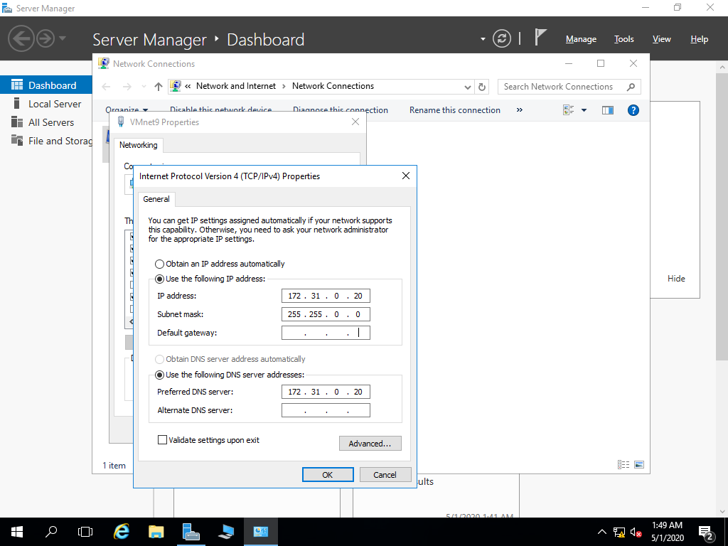

And I also changed the computer host name to DC .

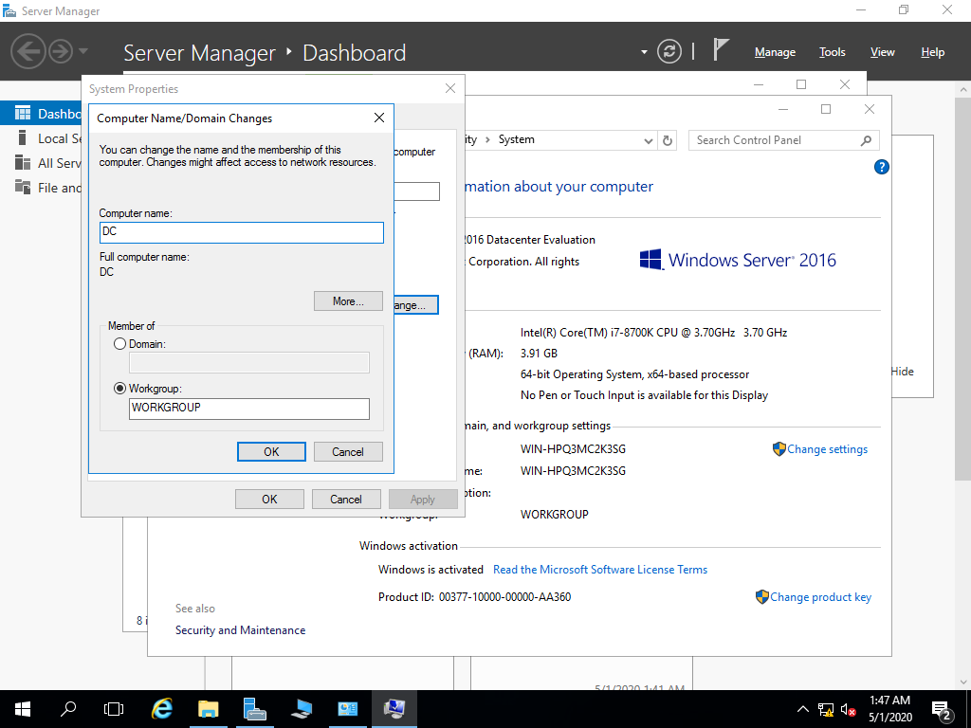

# 2.1 Promoting "DC" to Domain Controller

On "Server Manager" we will go to Manage > Add Roles and Features > Role-based or feature-based installation > Select "DC" .

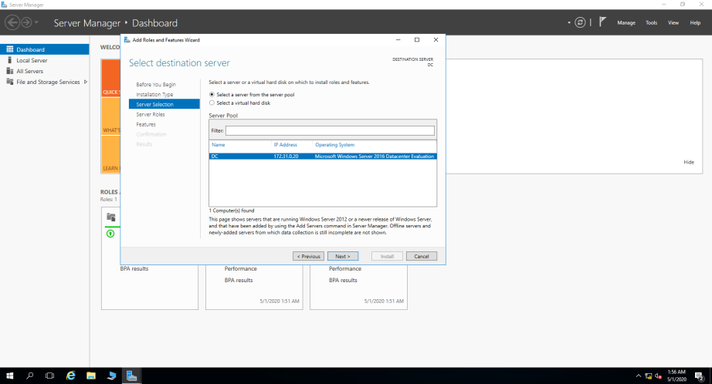

Afterwards we select Active Directory Domain Services role and install it.

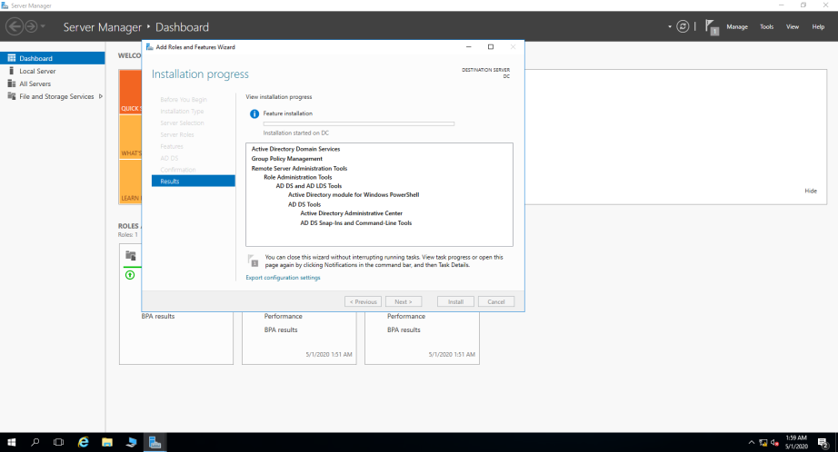

After installing this role , I promoted the server to a domain controller.

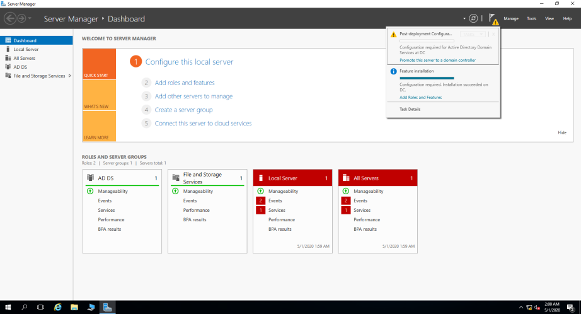

Now I chose "Add a new forest" because this is the first domain I created and named it Shimos.local .

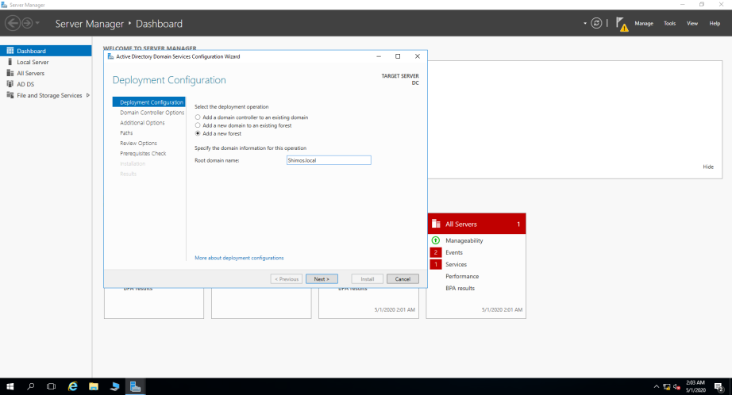

In this window I made sure the domain controller will have a DNS Server so I ticked the option and I chose a strong password that contain upper and lower case letters , numbers and symbols .

I also made sure the forest functional level will remain "Windows Servers 2016" because I have no reason for the domain to support lower versions.

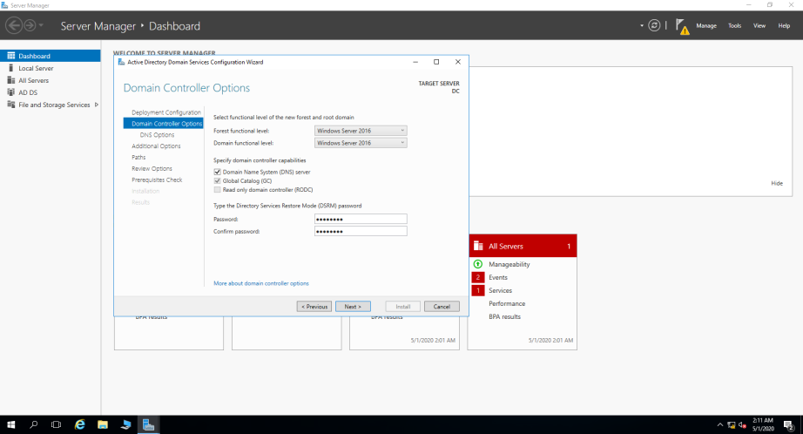

In this window I can see the NETBIOS domain name.

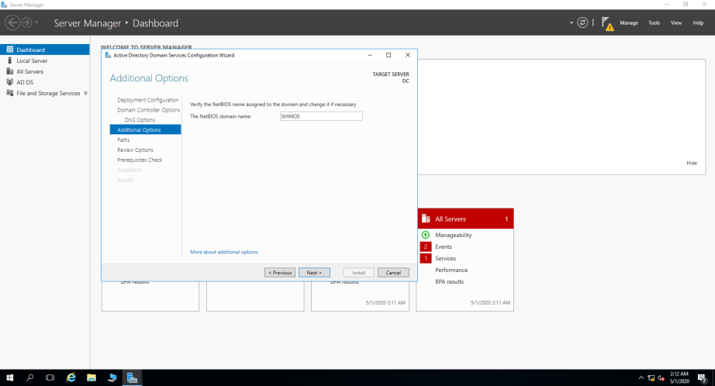

Here I can see where is my NTDS.dit file located , this file contains everything that is stored in our Active Directory (users , groups , passwords(!!) ).

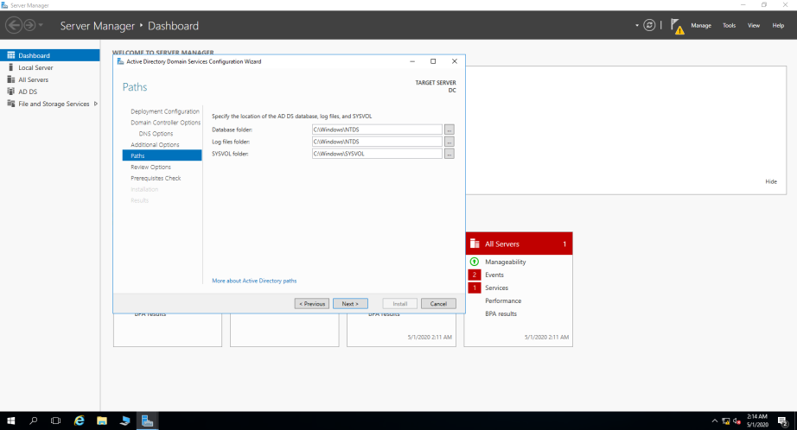

After I finished the promotion of the server to domain controller I shutted down the server and created snapshot "DC Promo" ( Creating snapshot while the server is offline is the best way because if you create snapshot while the server is still on the snapshot file size will be very large about the size of the RAM used )

I turned the server on and went to the IPV4 settings via NCPA.CPL to make sure my DNS Address didn’t change during the promotion of the server to a domain controller .

I also pinged my client to make sure they can still communicate with each other and im getting a normal response .

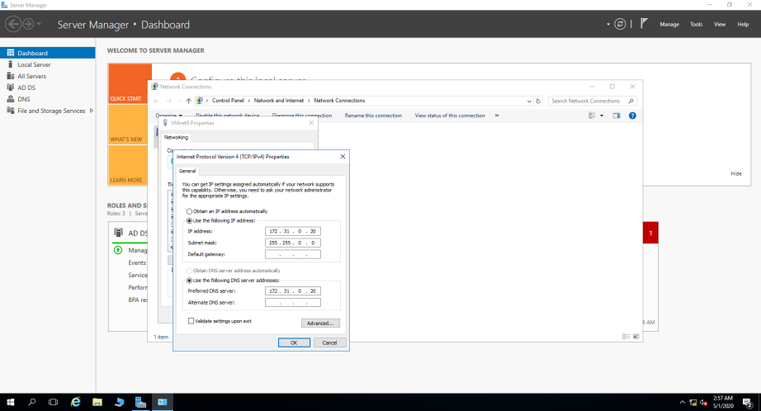

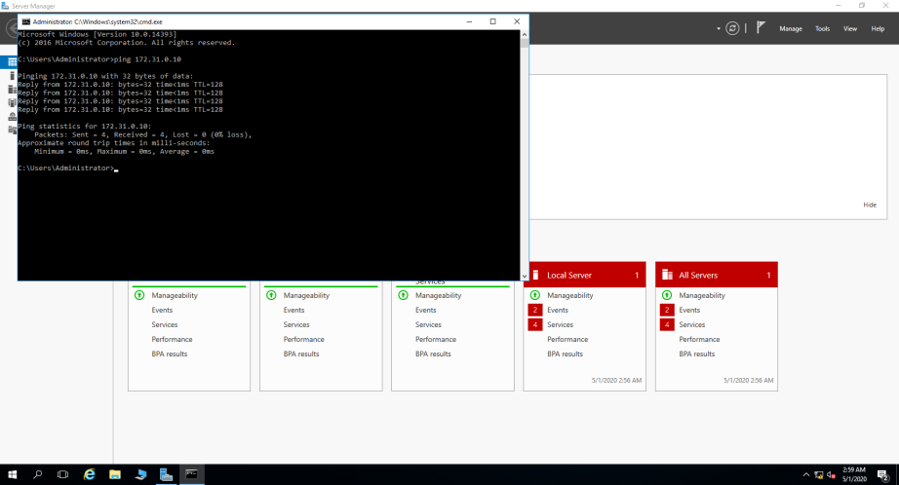

## 2.2 Creating 2 organizational units (OU) and groups

In order to create OU on the server we will go to Tools > Active Directory Users and Computers or typing DSA.MSC on the command line .

Right click on the domain > New > Organizational Unit.

I created 2 OU's – Sales and SysAdmin .

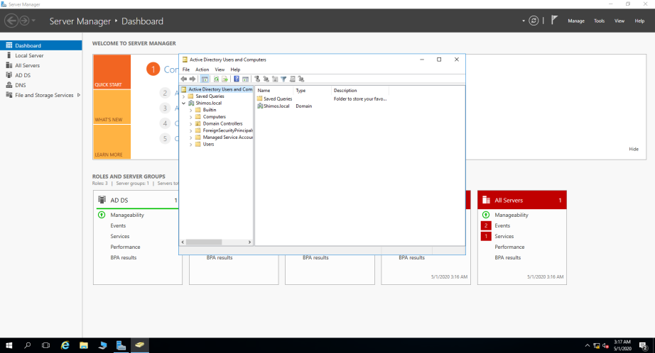

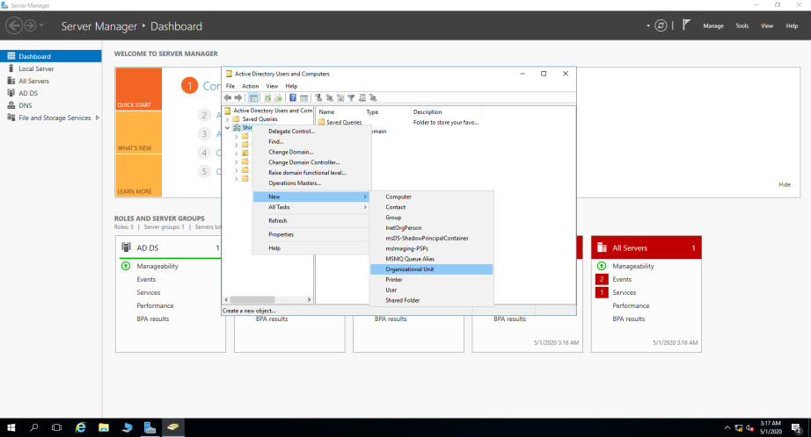

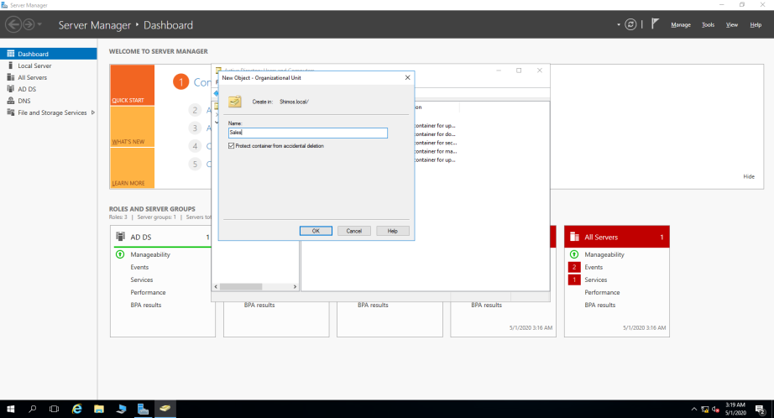

Afterwards I created 2 users in each OU , User1 + User2 in Sales OU and User3 + User4 in SysAdmin OU.

I gave them strong password , ticked "Password never expires" and "User cannot change password".

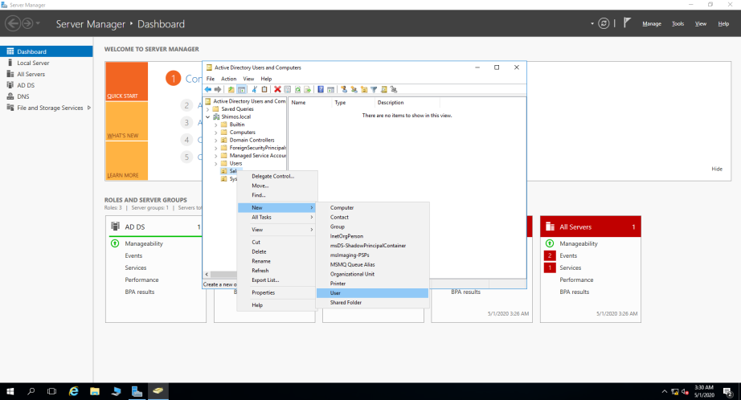

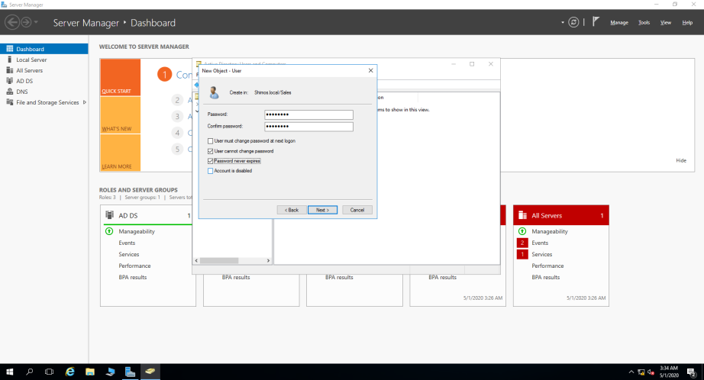 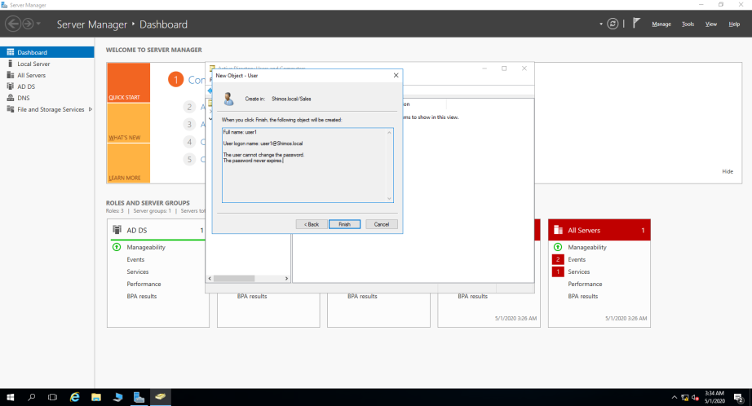

Now I created "Sales" and "SysAdmin" group under each OU and added the users accordingly (1+2 Sales , 3+4 SysAdmin) with "Global" and "Security" settings (because the users are not "only mail" users and then added the users to each relevant group ( right click on user > Properties > Member of > Add > type the group name > Check Names > Apply > Ok ).

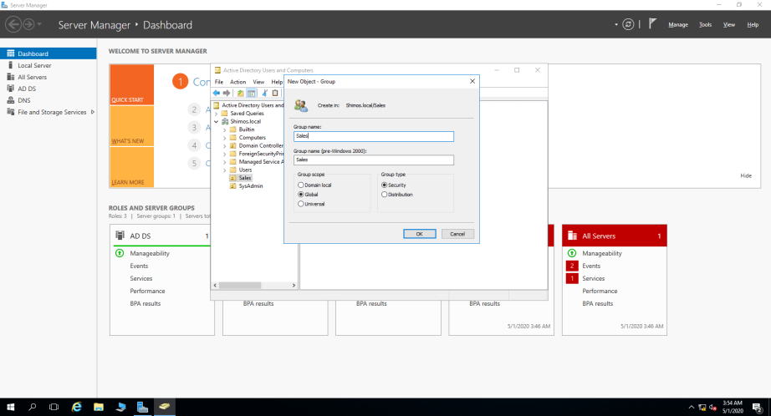

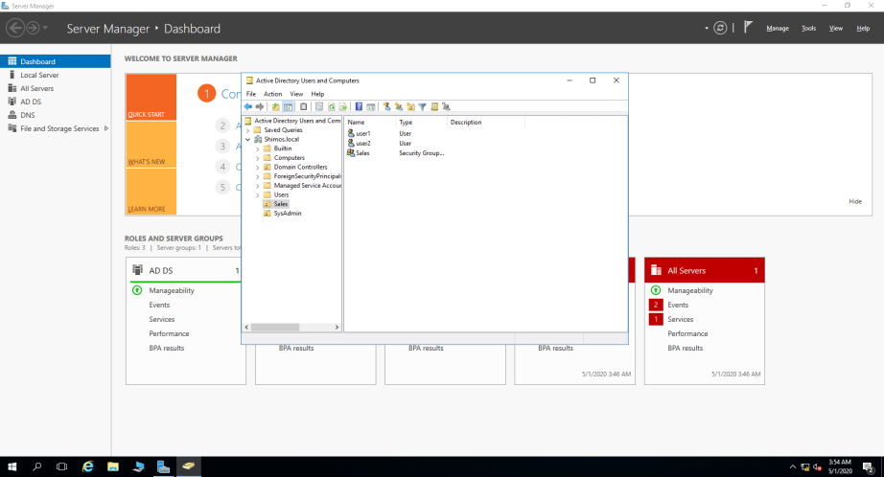

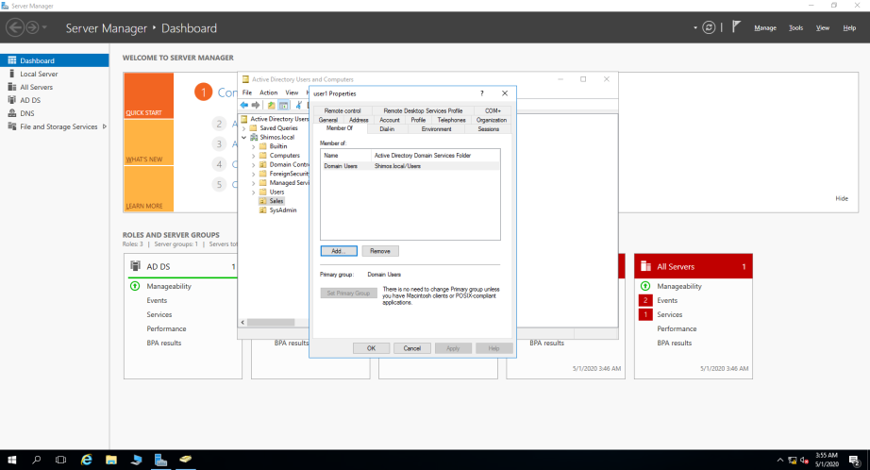

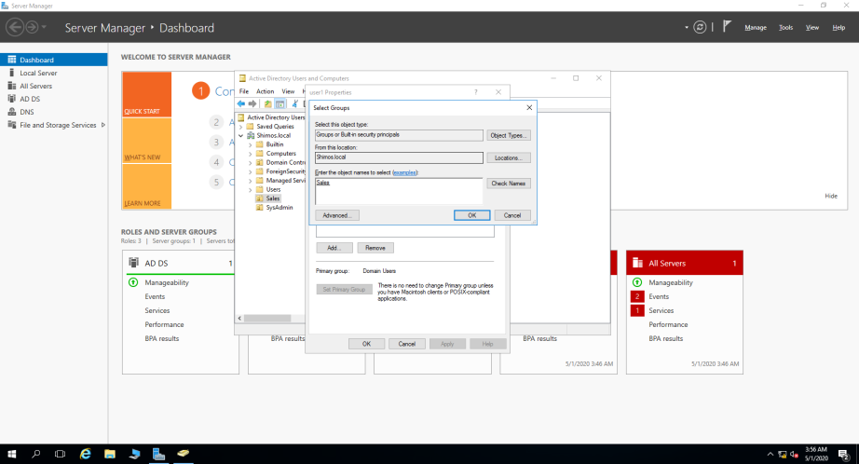

I also added SysAdmin group to the Domain Admins group so users user3 and user4 will have administrator rights.

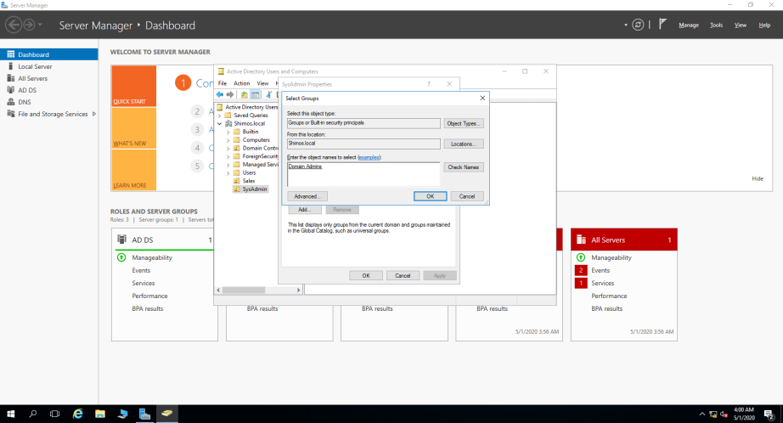

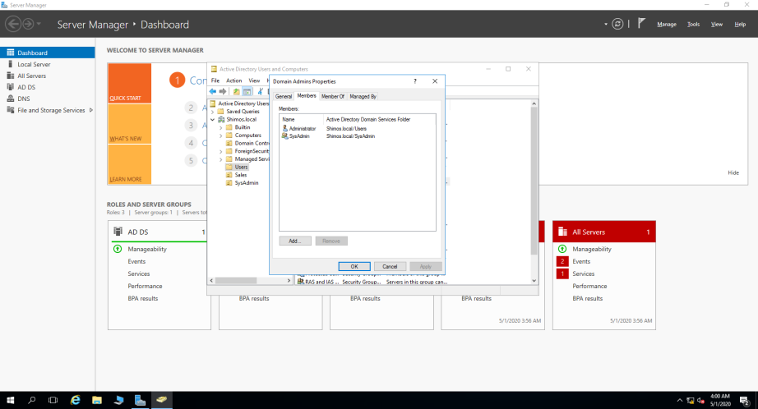

# 3.1 Configuring DHCP server

I will install DHCP server on the DC now so the DC will give domain clients IP address automatically.

Before that , I will check that my DC's IPV4 settings remained the same and that I have a permanent IP.

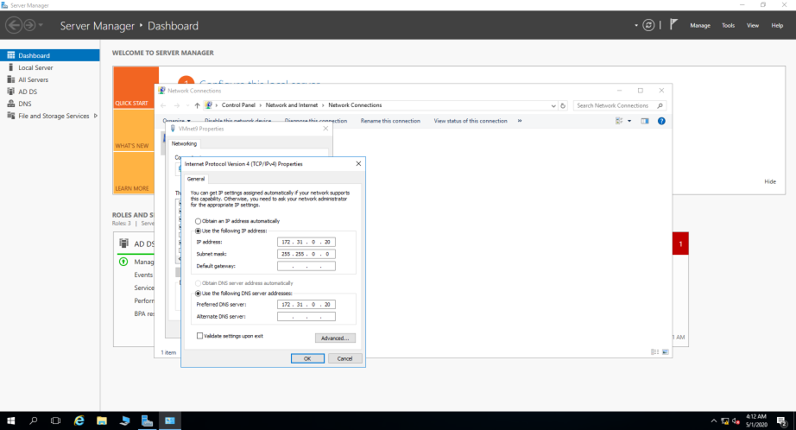

Then I will go to Manage > Add Roles and Features and start the DHCP installation wizard.

I also made sure that my DC Server IP is correct in the installation wizard.

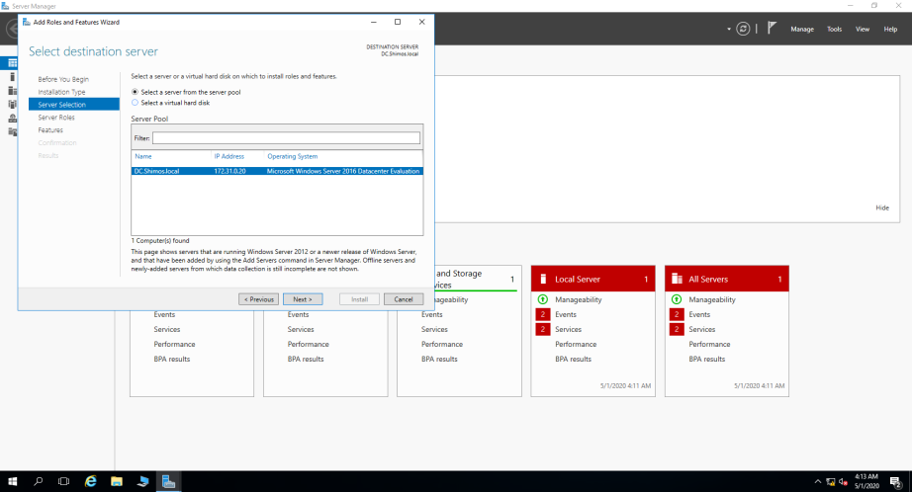

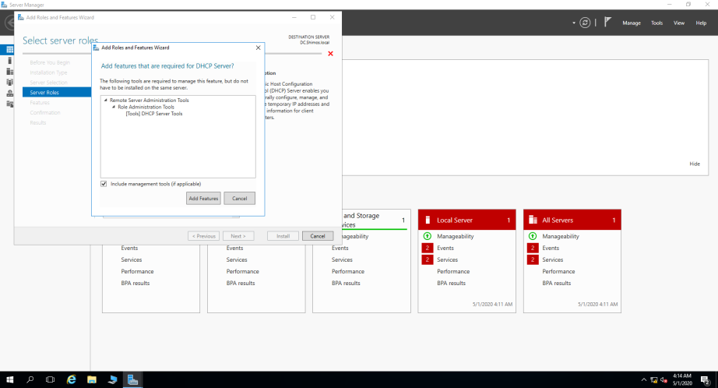

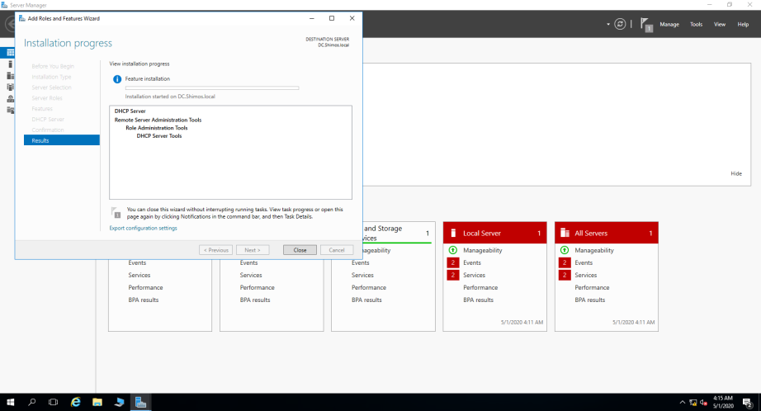

. I completed the DHCP Configuration

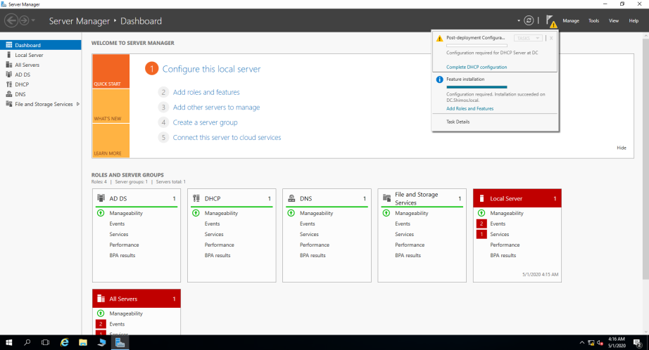

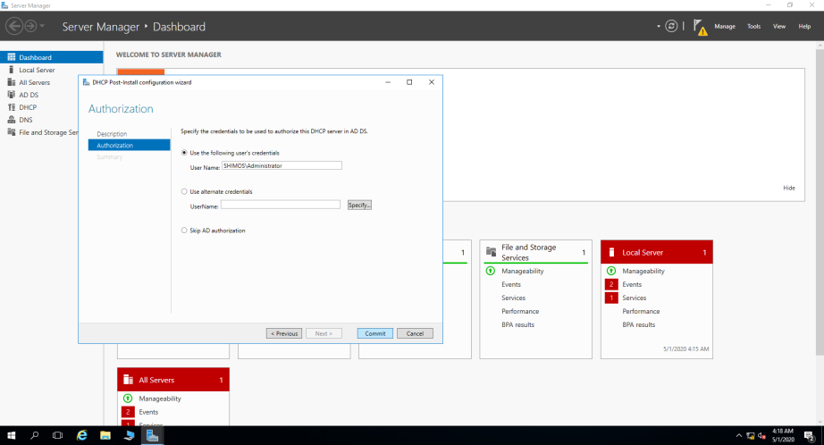

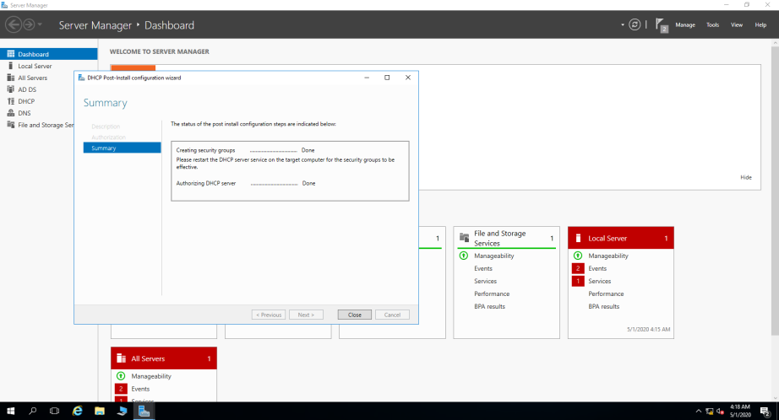

# 3.2 DHCP Scope

Now I will create a DHCP scope of 50 IP Addresses so it will give the domain clients IP Address automatically so I won’t have to go to each client and set their IP manually.

Tools > DHCP > Right click on IPv4 > New Scope.

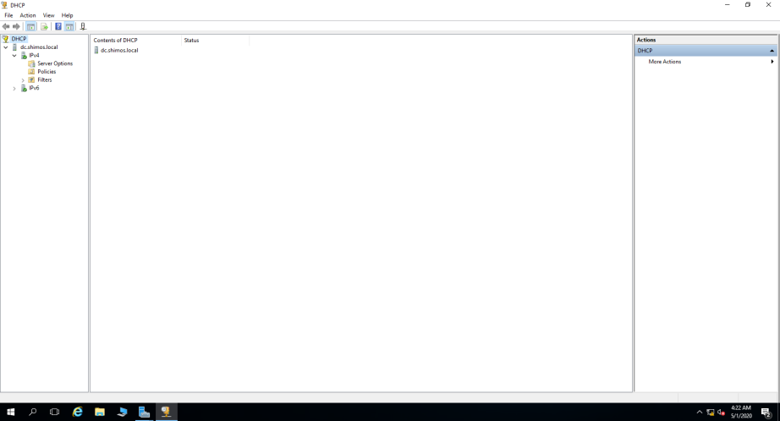

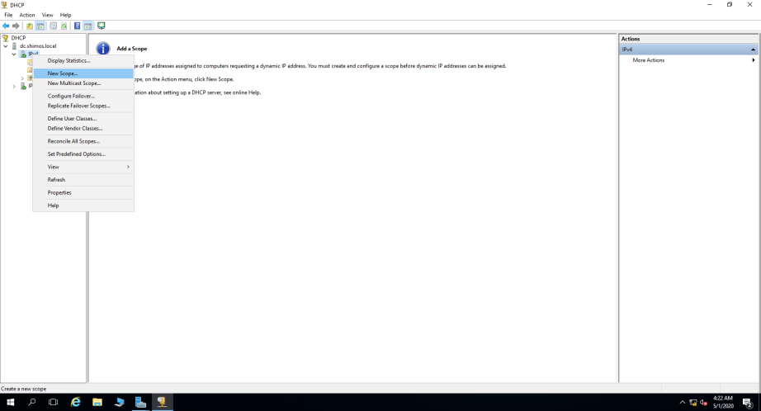

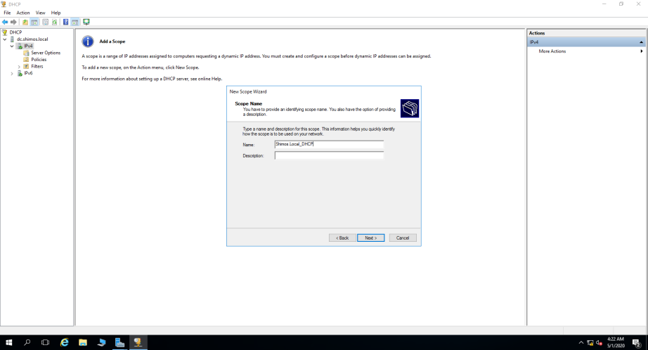

I configured the IP Address range to give IP's from 172.31.0.1 to 172.31.0.50.

### 3.3 DHCP Exclusions

I made an exclusion for the DC IP Address and the first 5 IP Addresses on the scope

172.31.0.1 / 172.31.0.2 / 172.31.0.3 / 172.32.0.4 / 172.32.0.5 .

Excluded DC IP 172.32.0.20 .

And for 172.32.0.50 as it’s going to be our router ip.

I setted up a lease duration of 8 hours.

I also configured DHCP options – I configured the router IP Address to 172.31.0.50 as its going to be our default gateway .

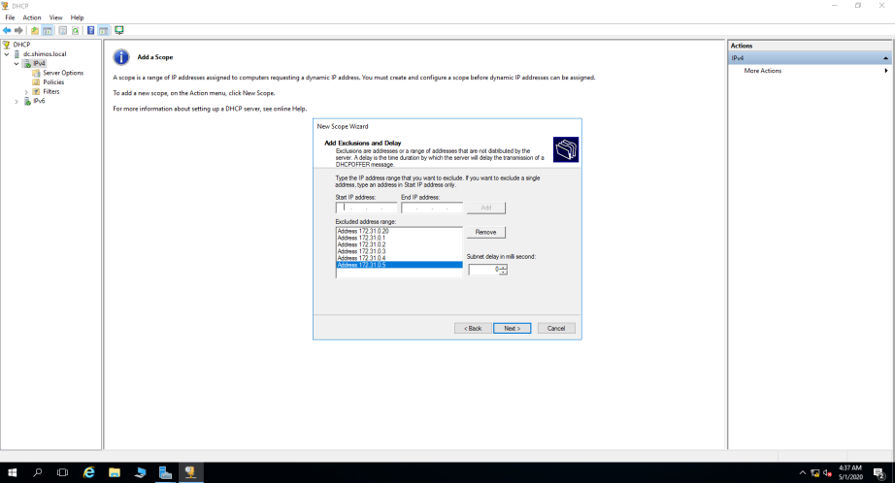

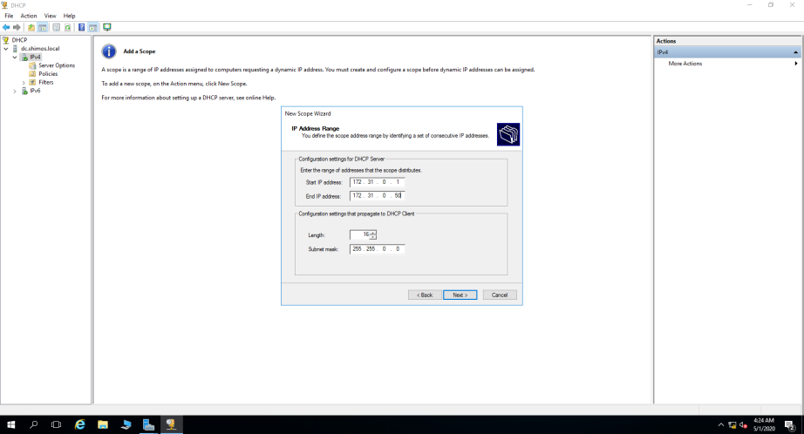

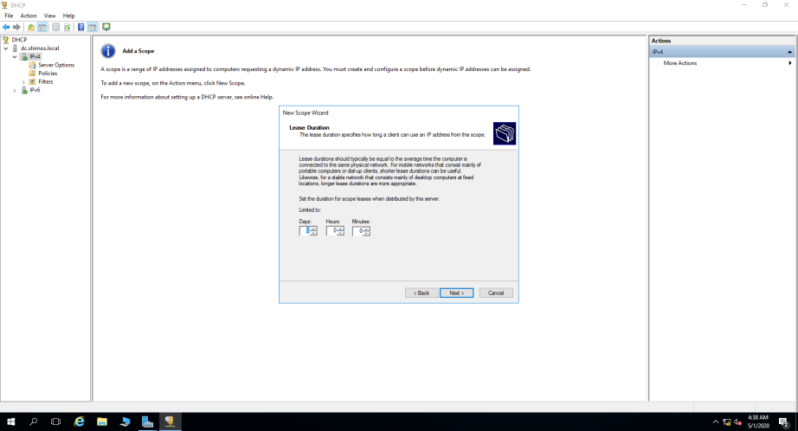

#### 3.4 DHCP Options

On this window I told the DHCP to route the clients to the DNS which is 172.31.0.20 (the DC is our DNS Server) so now the DHCP gives IP Addresses and DNS addresses.

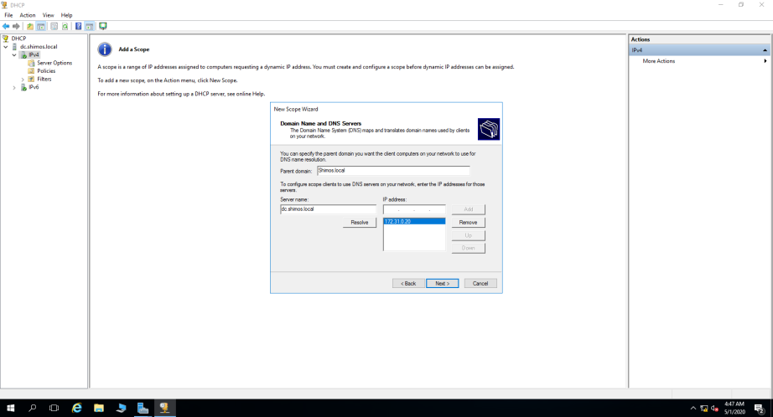

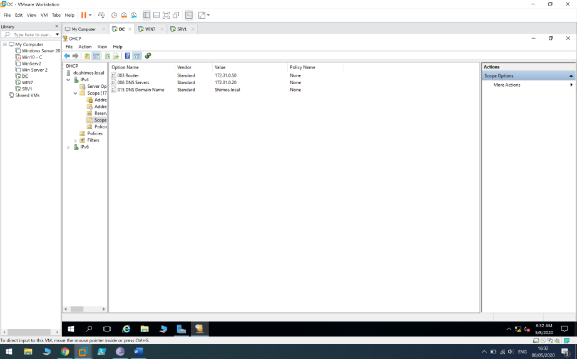

##### 3.5 Connection Check

I finished the DHCP Server installation and configuration and I went to my client (WIN7) , Added it to the domain shimos.local , changed the IPV4 settings to automatically and checked

1) DC and WIN7 has connection between them

2) The client is getting IP address and DNS Server address

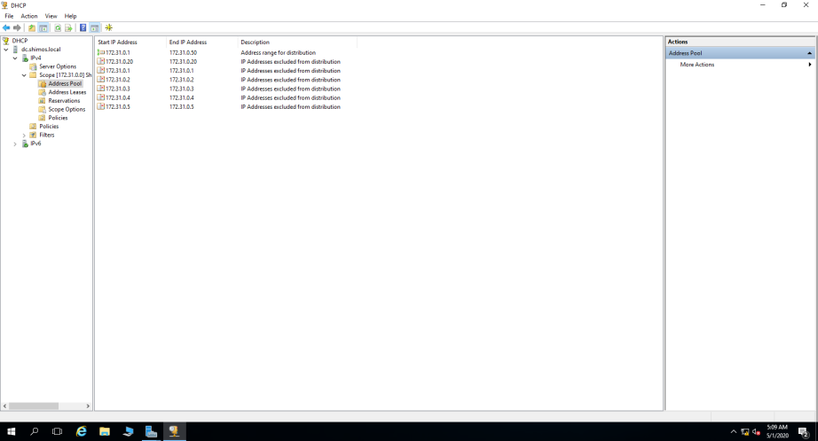

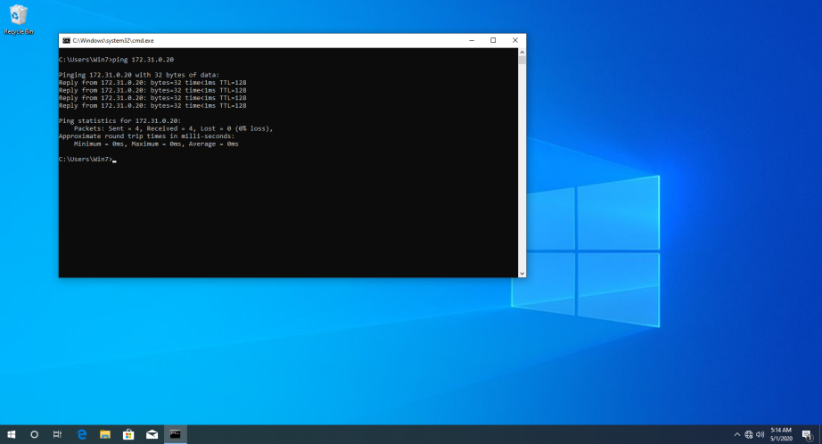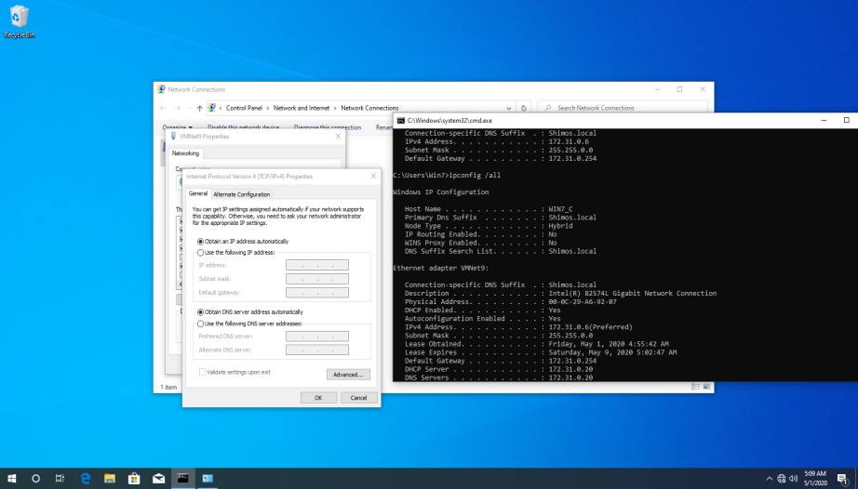

DC to WIN7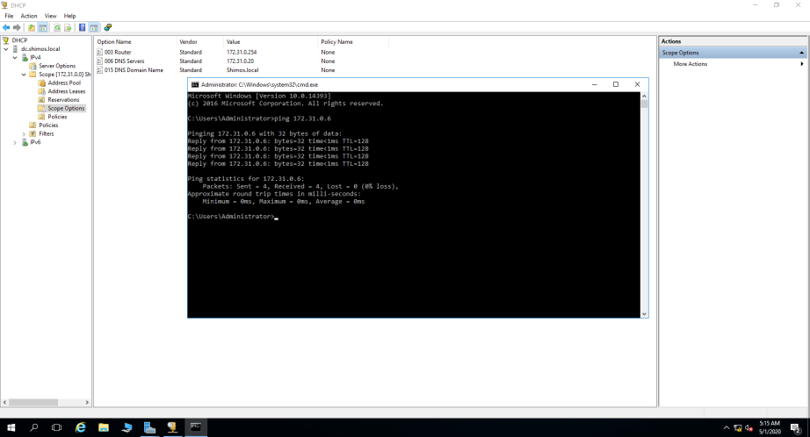

# 4 Adding SRV1 and WIN7 to shimos.local domain

I added SRV1 and WIN7 clients to the domain - This PC > Properties > Change Settings > Change > Type domain name.

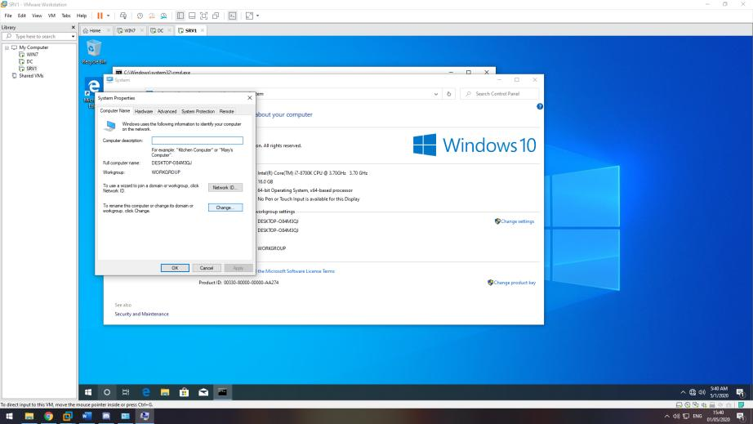

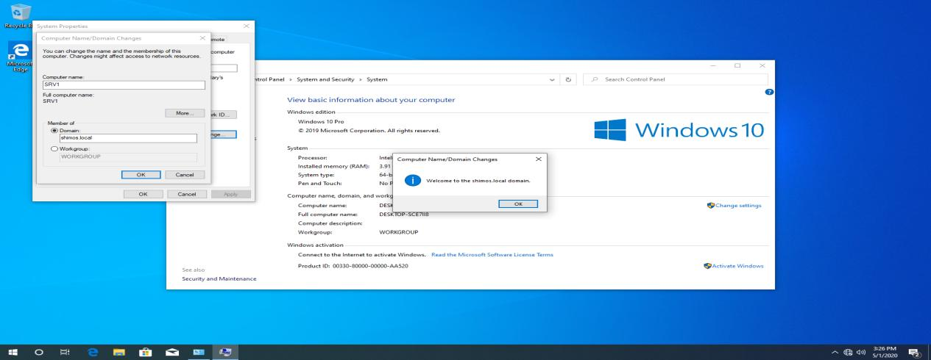

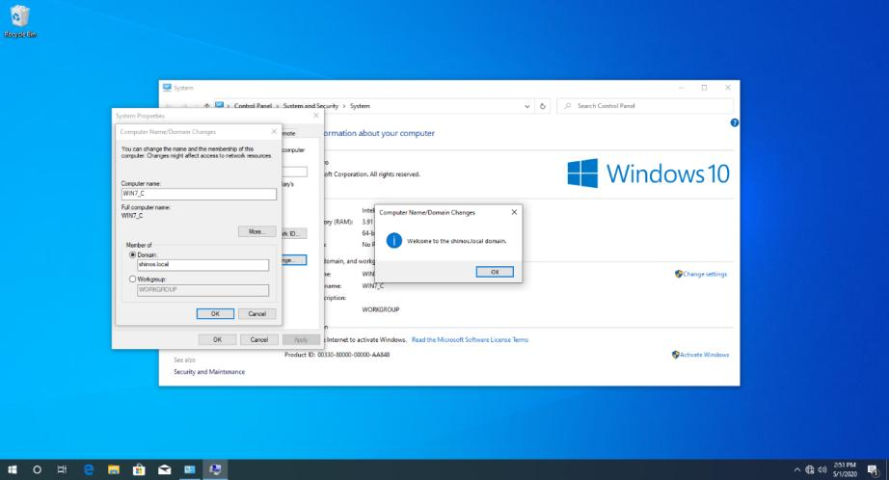

# 5.1 Installing Router and Remote Access service on SRV1

I excluded the last IP Address on the scope for my router ( 172.31.0.50) and I configured static IP on SRV1 because I don’t want any IP changes or interruptions to occur on the router client (SRV1) (clients who provide services should always have static IP like Domain Controller).

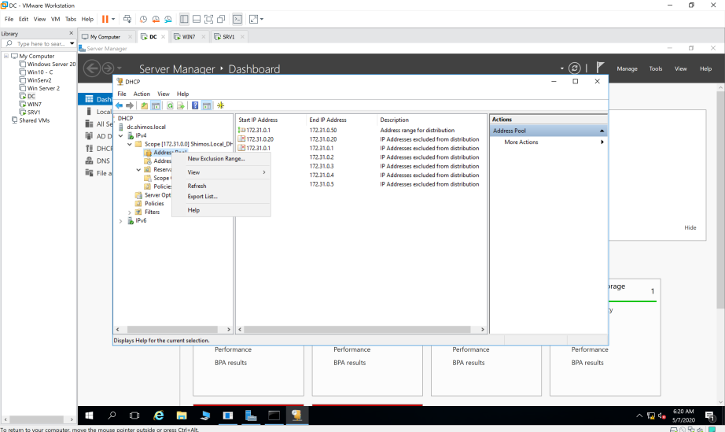

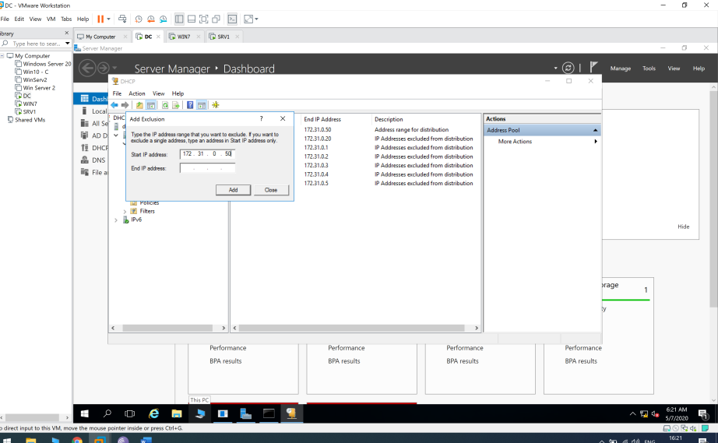

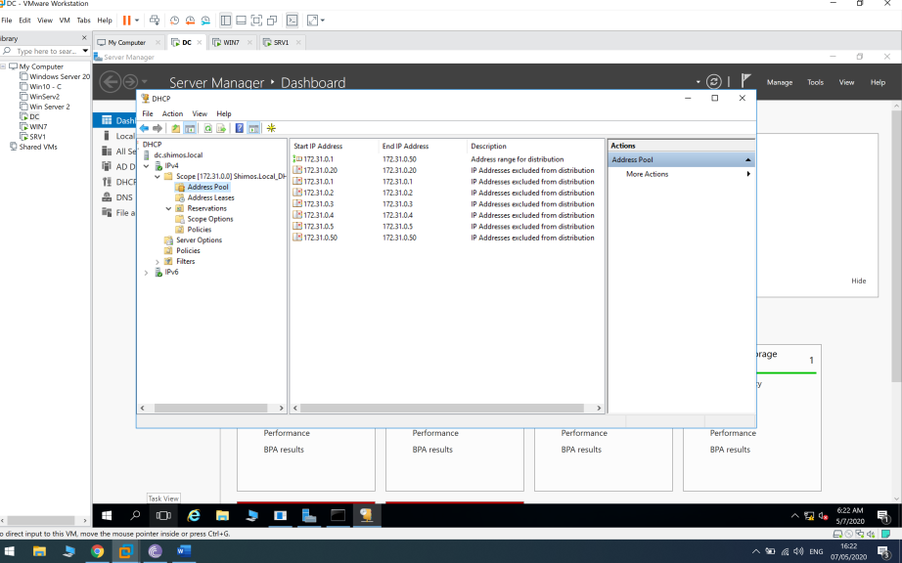

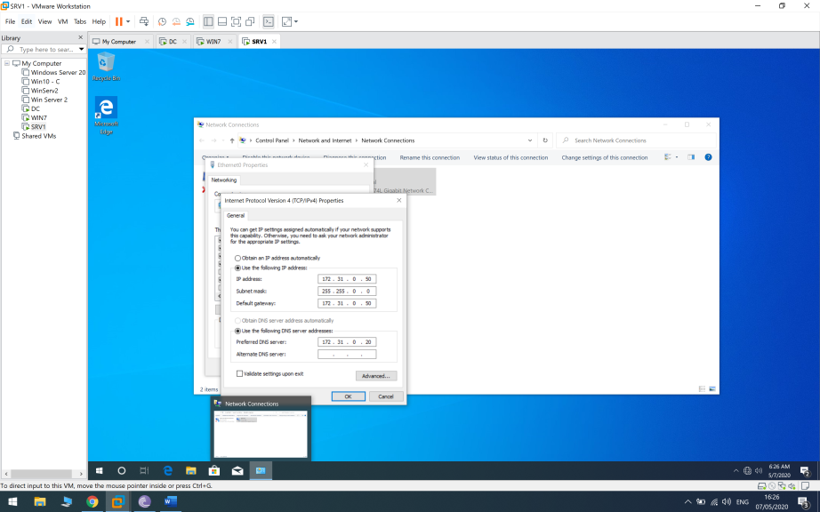

Now I added network adapter (Bridged) to our SRV1 client so it will get internet access from the host router (my house router) and then every client on the domain will get internet access via SRV1 because it’s the default gateway.

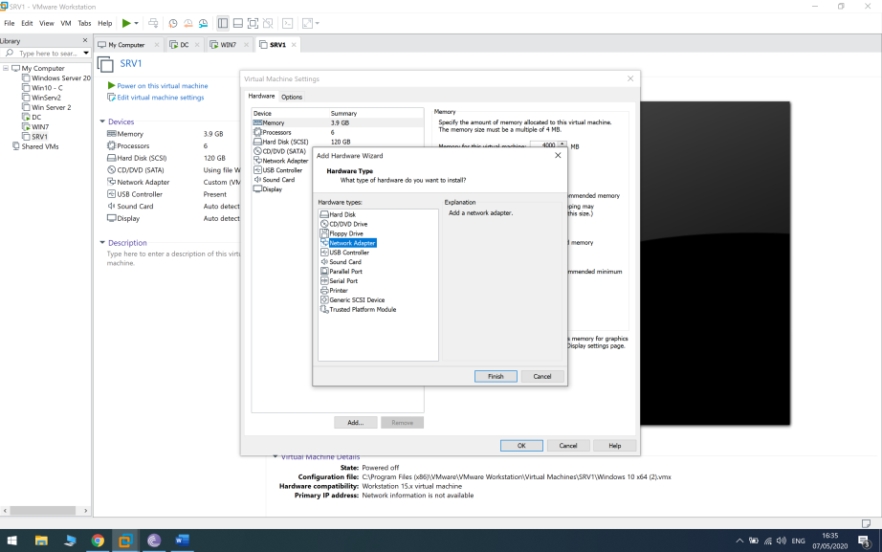

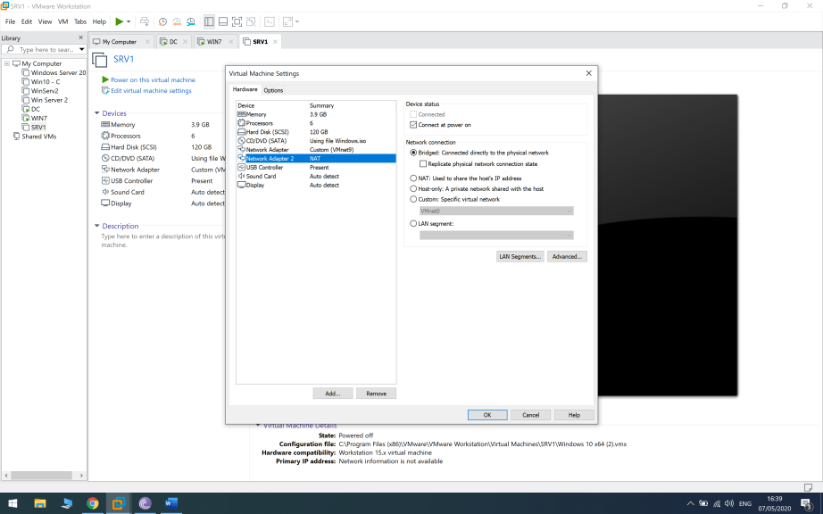

Now I pinged 8.8.8.8 to make sure I have internet connection on my SRV1 client.

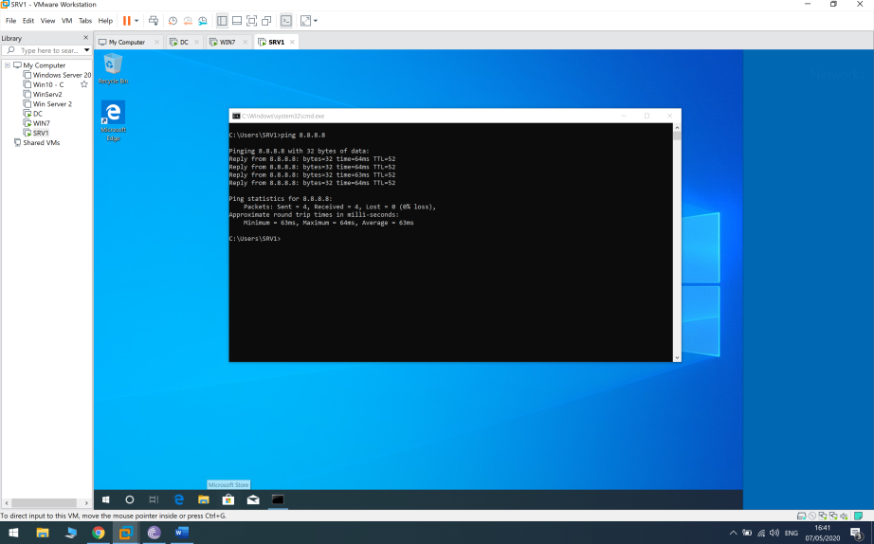

We will install the remote access role ( Manage > Add roles and features)

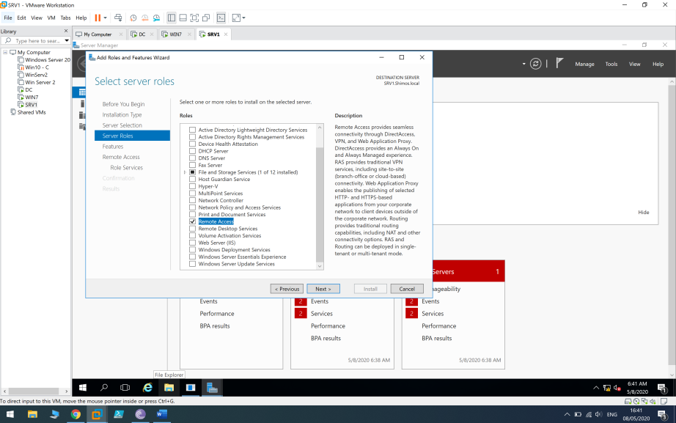

Tick Routing (DirectAccess and VPN will be automatically ticked because they are depended).

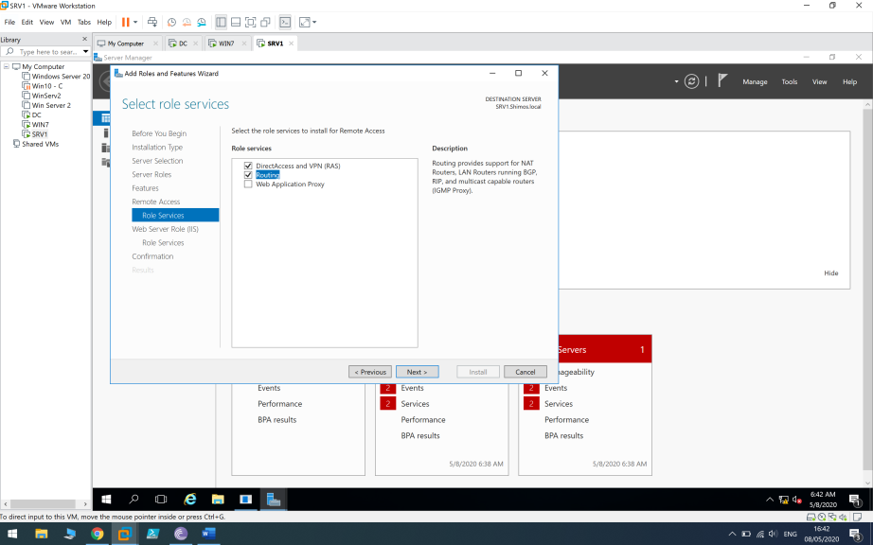

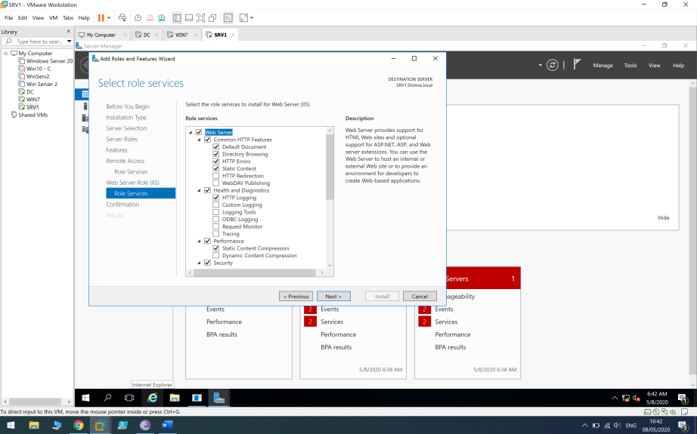

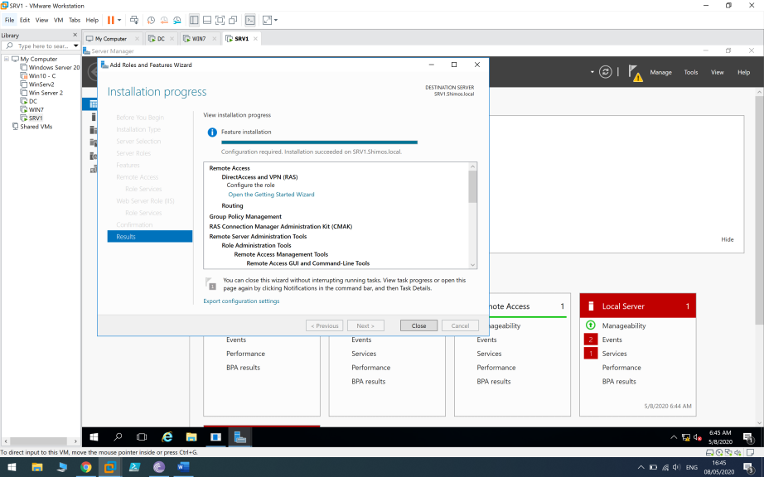

I made sure the client WIN7 has not internet access before I start configuring the remote access settings

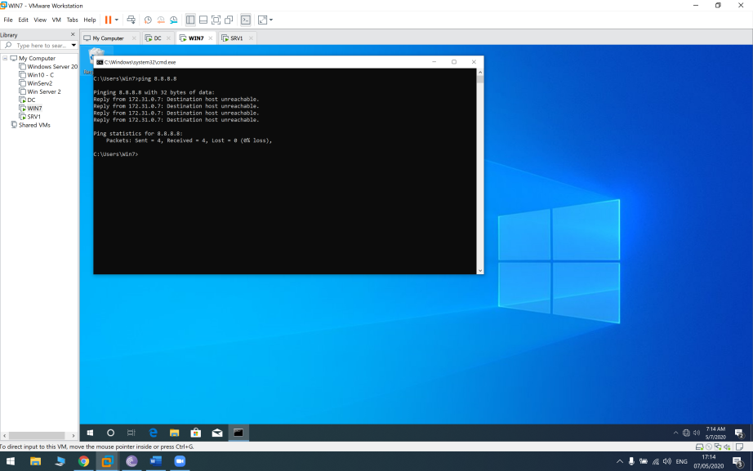

I go to Tools > Routing and Remote Access and then configure the Routing and Remote Access settings .

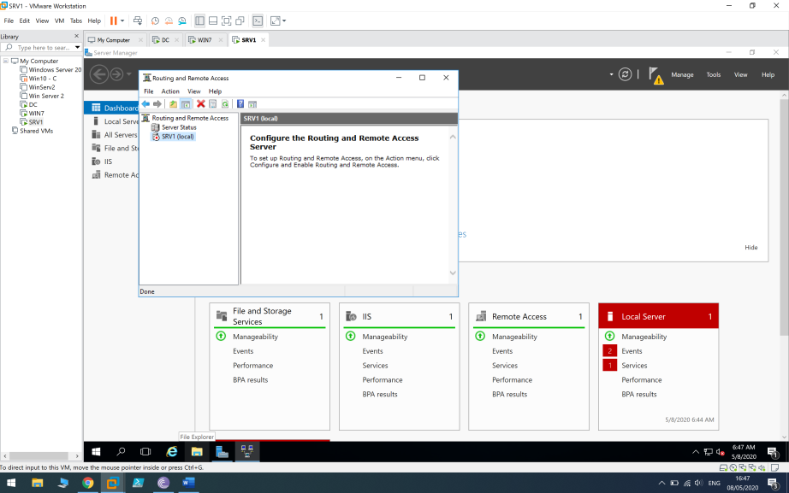

Right click on SRV1 (local) > “Configure and enable routing and remote access”.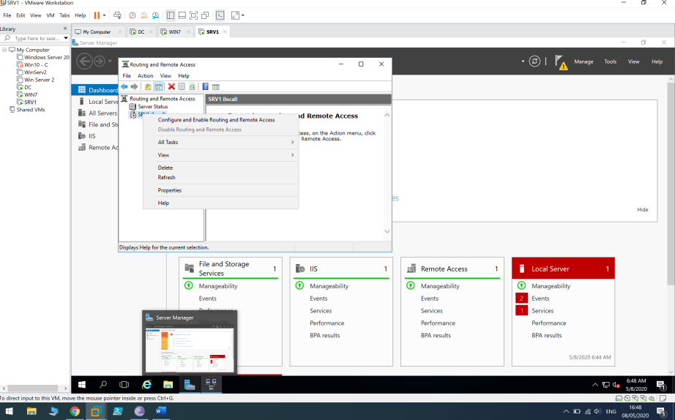

Tick NAT (Which is also PAT)

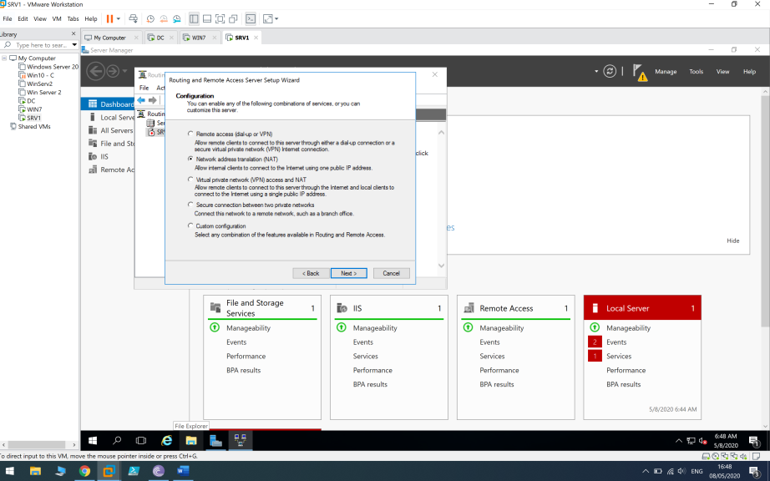

We choose the Bridged interface because it has the connection to the internet and we want all our clients will use this interface to reach the internet .

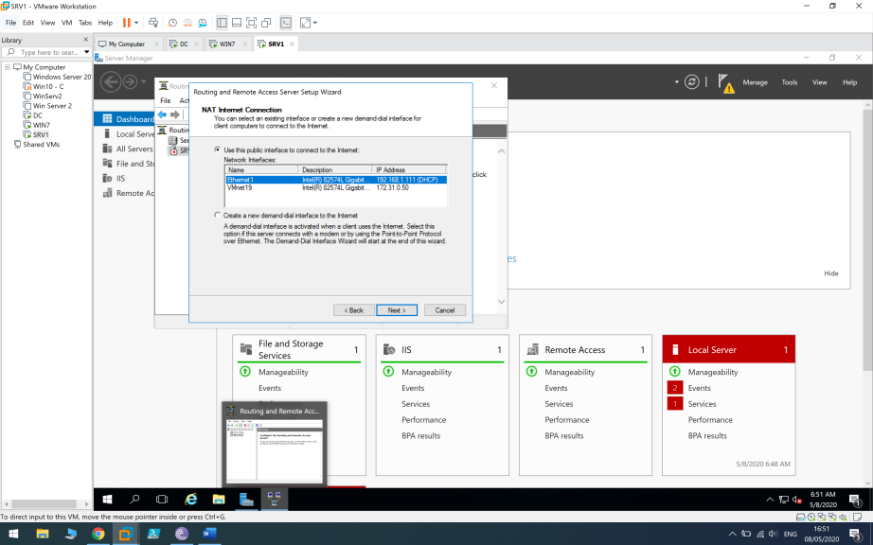

## 5.2 Internet access check

The installation and configuration of the Routing and Remote Access role is finished ,I will check that our clients have access to the internet .

Ping google.com from WIN7

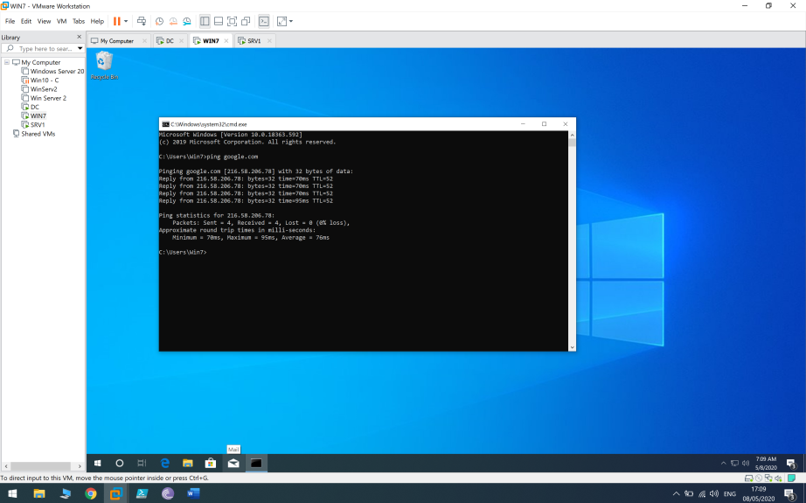

Ping google.com from DC

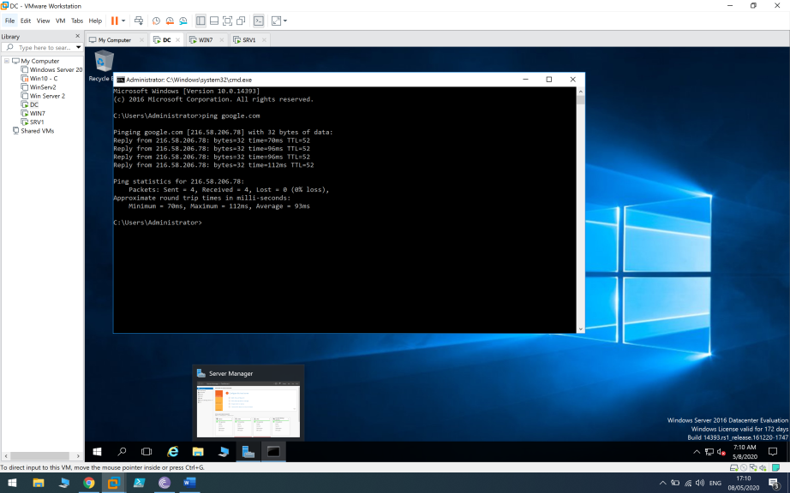

Using tracert command we see that the first hop is to the default gateway (SRV1) and then my home router

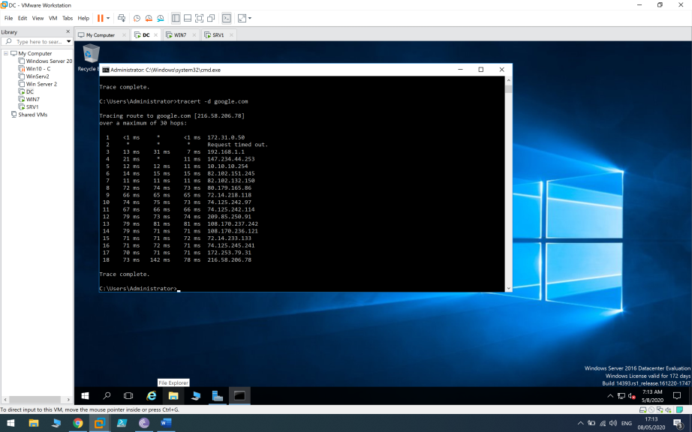

# 6.1 DNS Server

First I will make sure that every client is using the DC DNS (on the SRV1 ill configure static DNS on ethernet settings)

I will use two methods to see they are using the DC DNS ( 172.31.0.20) – nslookup and ipconfig /all on cmd.

WIN7-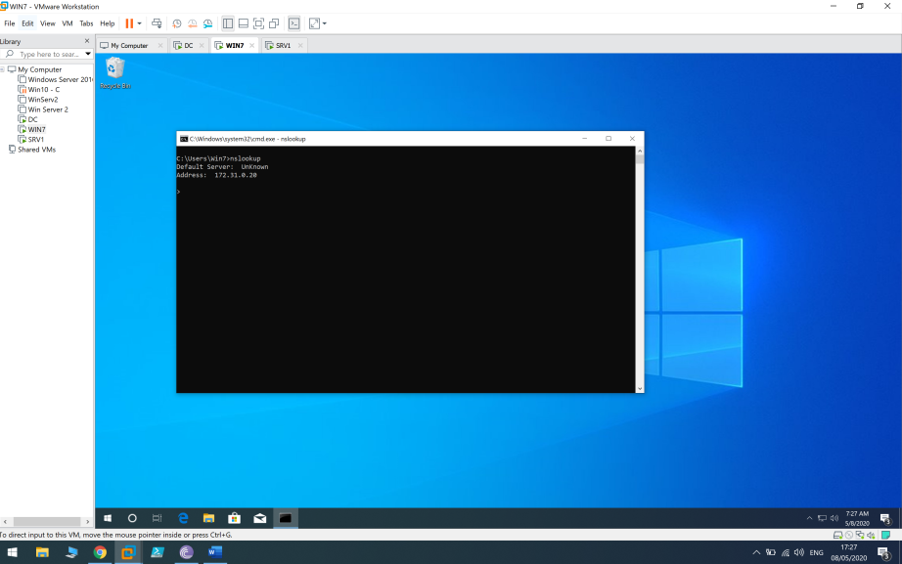

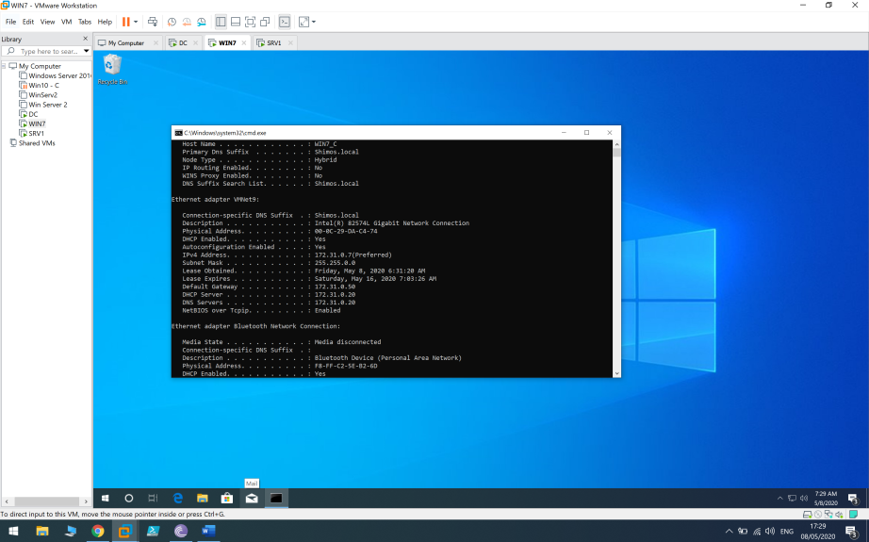

SRV1 bridged settings -

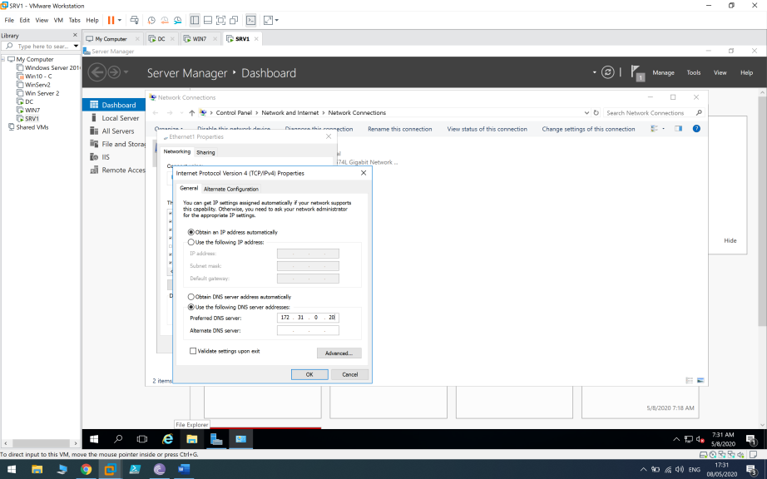

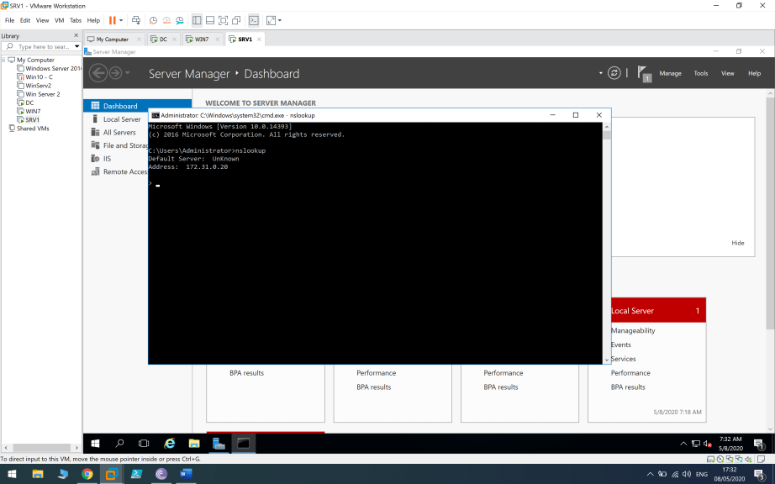

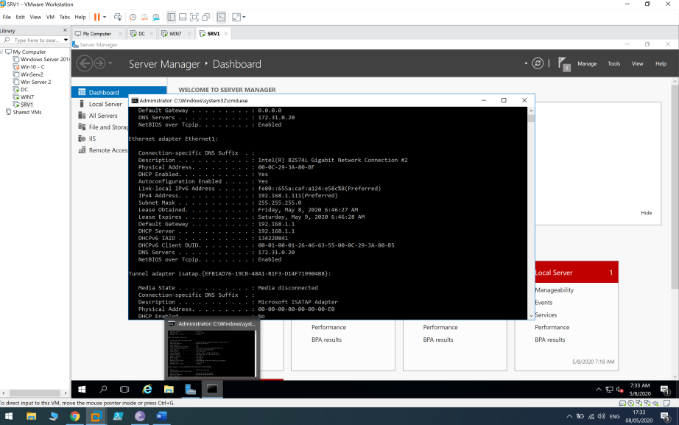

## 6.2 DNS Forwarder

I will now add DNS forwarder to resolve querys that the DC can’t resolve.

Server manager > Tools > DNS > Right click on DC > Properties > Forwarders > Edit > 8.8.8.8 (Google DNS Server) > OK

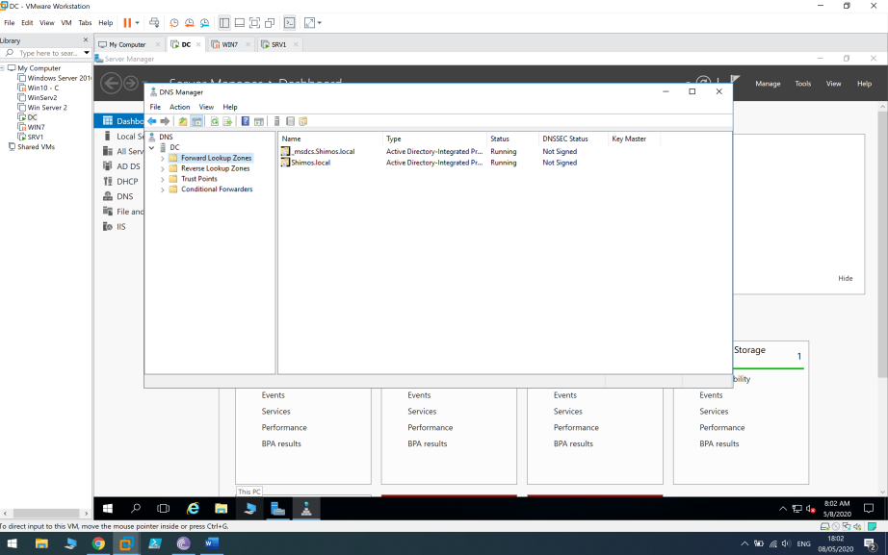

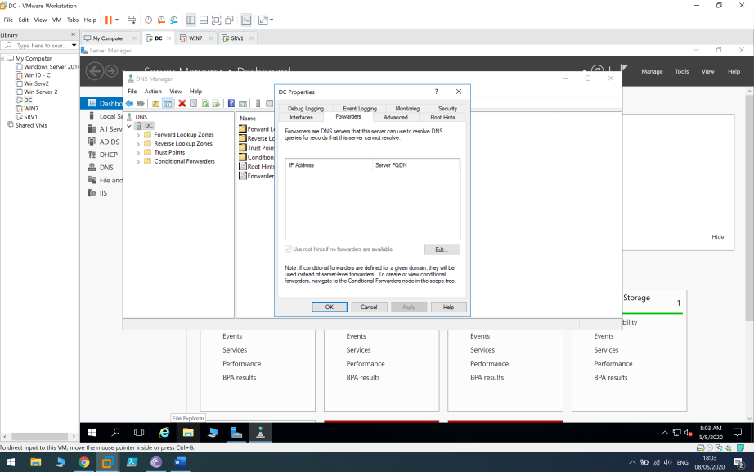

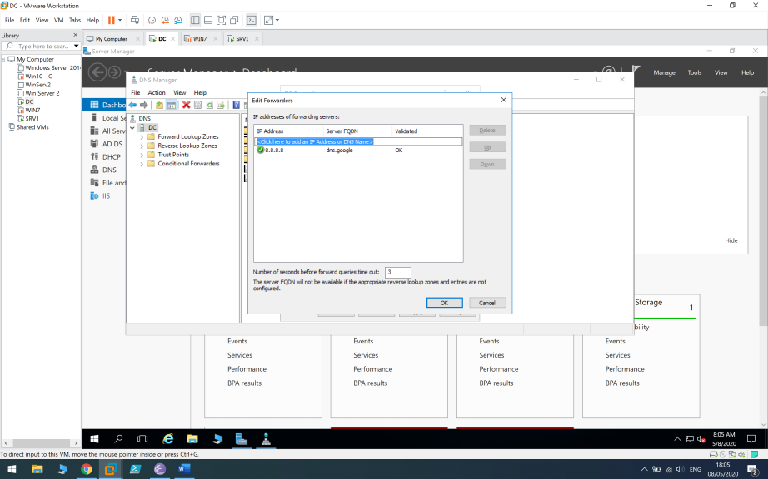

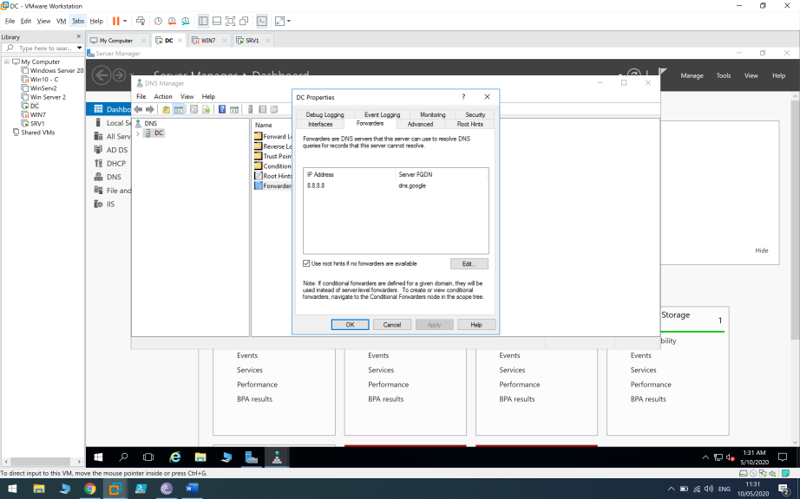

### 6.3 DNS Stub Zone

We will set a google.com as stub zone , right click on forward lookup zone > new zone

We choose stub zone

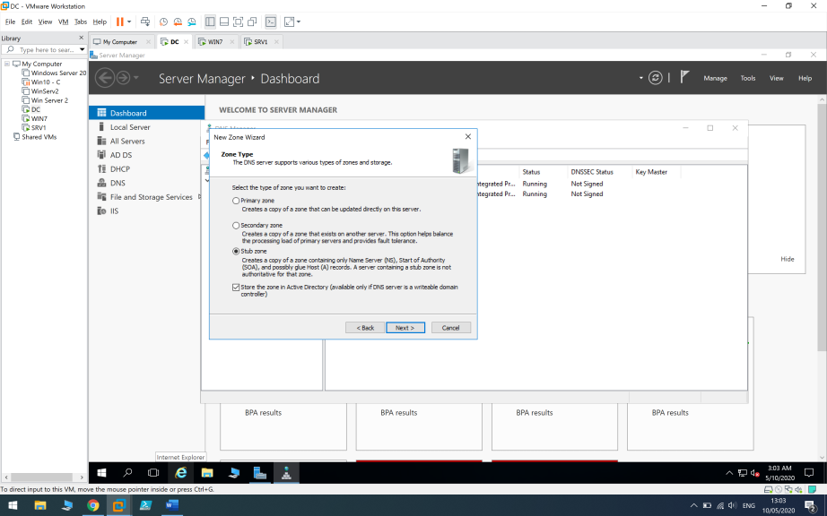

Now if we had another DNS server in our domain or forest the stub zone would replicate to it.

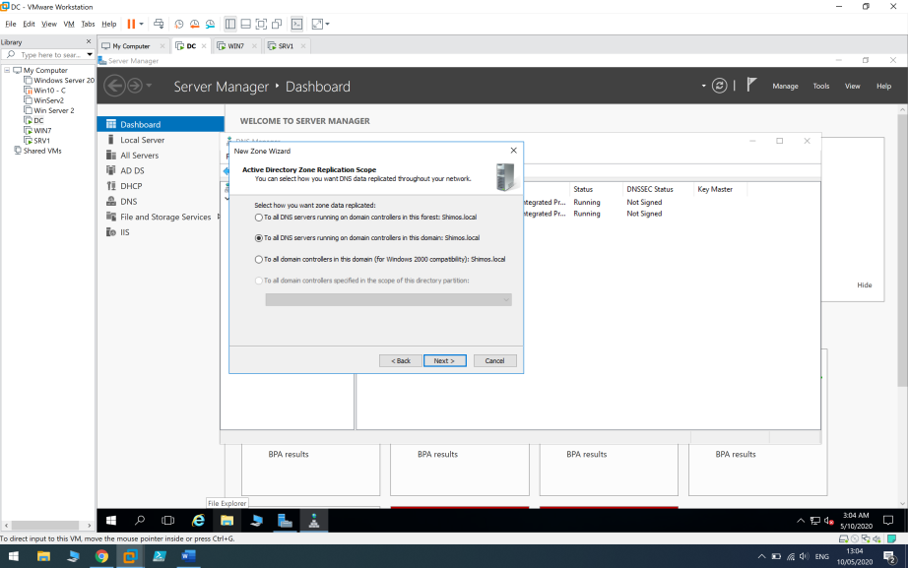

I delete the 2nd address and only 216.239.32.10 remains. 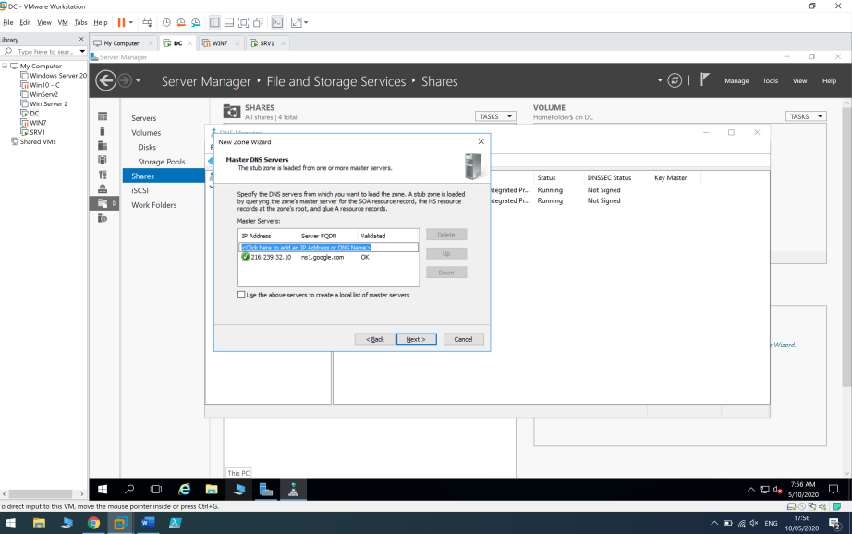

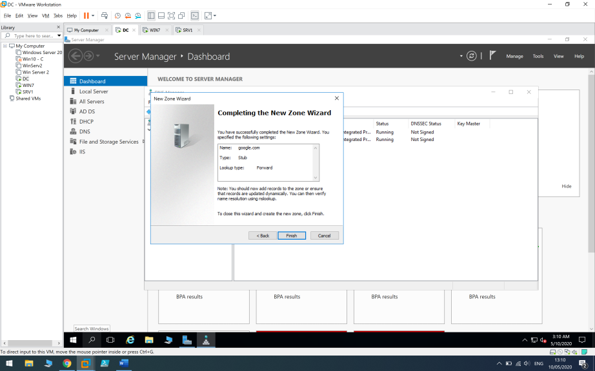

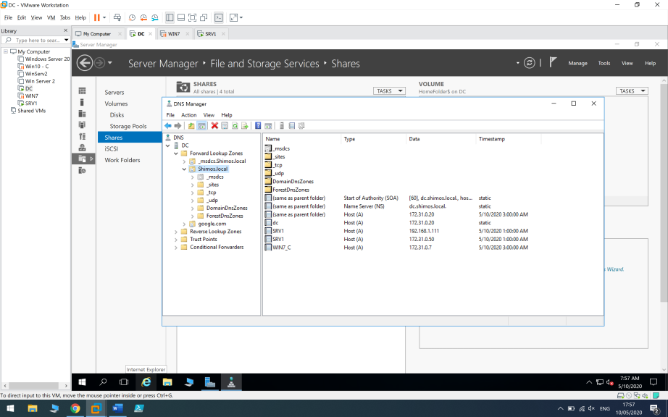

#### 6.4 nslookup

Now I will use nslookup command on WIN7 to check if the server can translate [www.google.com](http://www.google.com) –

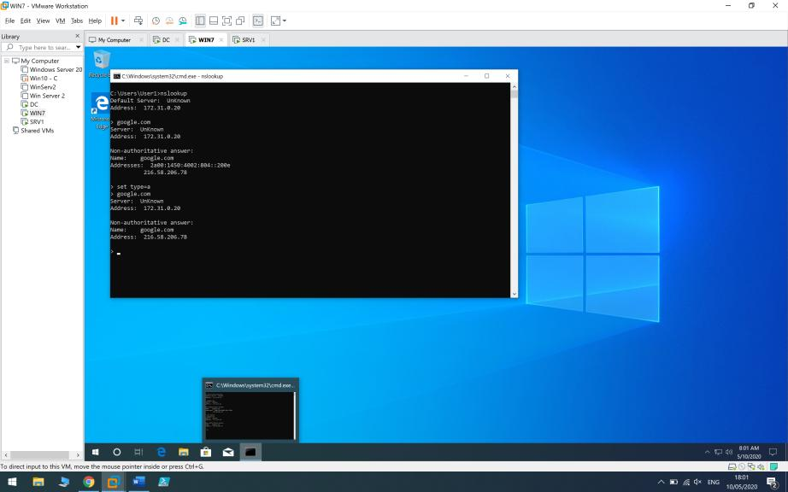

Now I will use nslookup command on SRV1 to facebook.com-

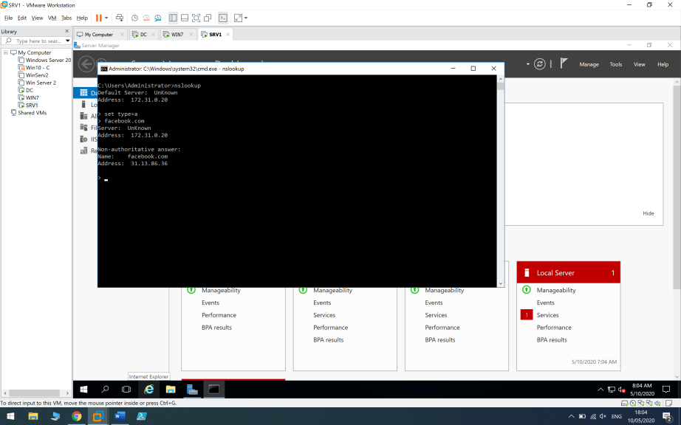

# 7.1 Home Folder

I will now create home folder which is private network location where users can store personal files which they can access to from every computer on the network.

First I will create new folder in my DC documents ( C:\Users\Administrator\Documents )

“HomeFolder” with “Project.txt” file in it.

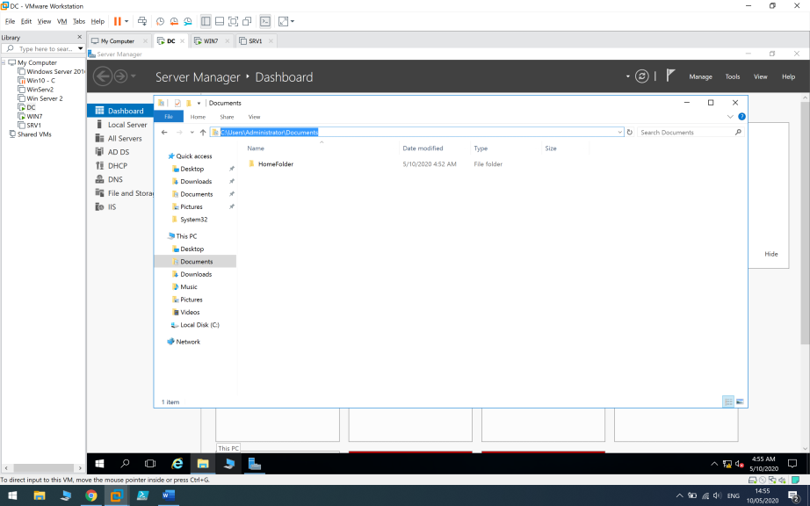

I will share this folder with the network – Right cllick > Properties > Sharing > Advanced > Share this folder.

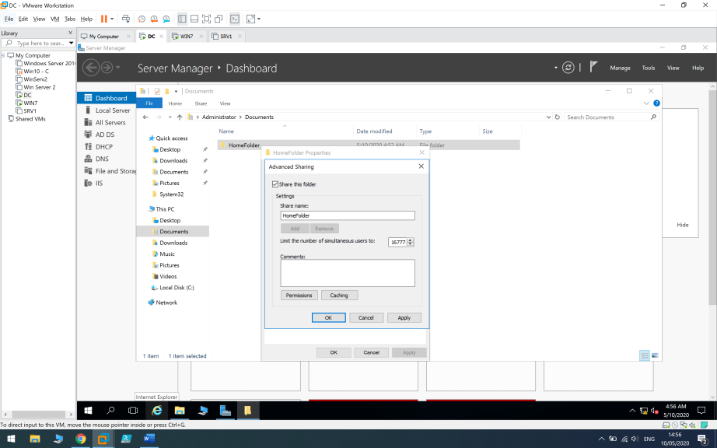

And on the security tab I will add “Users” group and will grant them full control permissions.

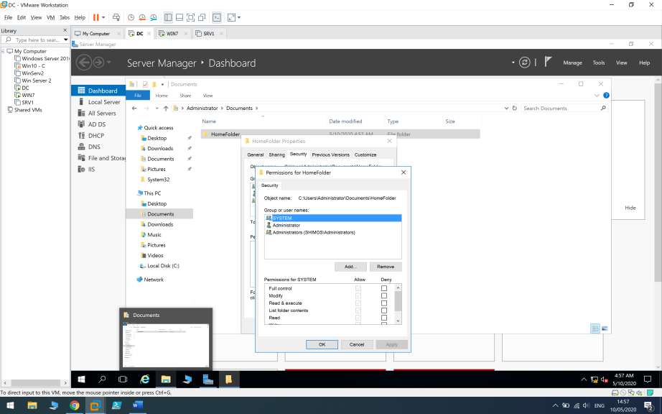

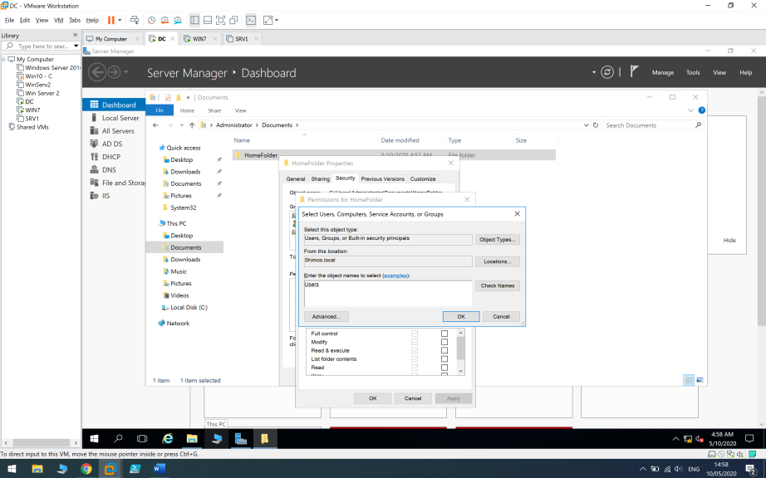

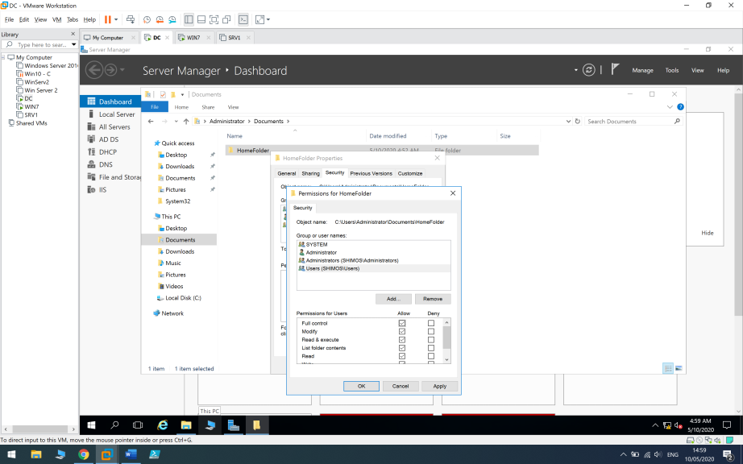

I go to WIN7 client with USER1 and type “ \\dc” (\\dc\homefolder is also an option) to see if the folder is shared among the users.

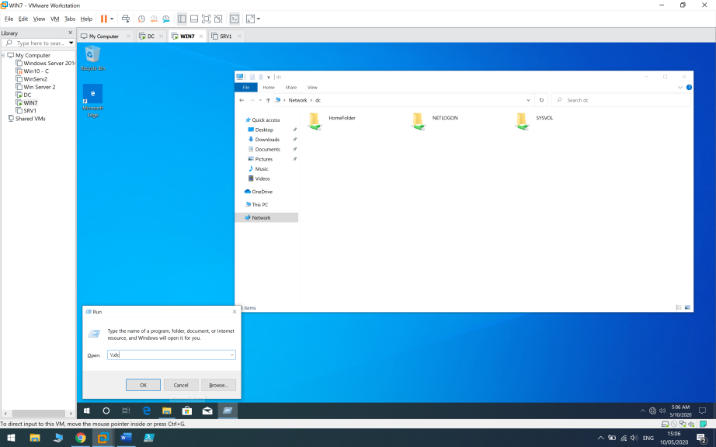

After I saw that the folder is shared , I will go to server manager > File and Storage Services > Shares .

I will create an SMB – Quick Share which is the most basic share.

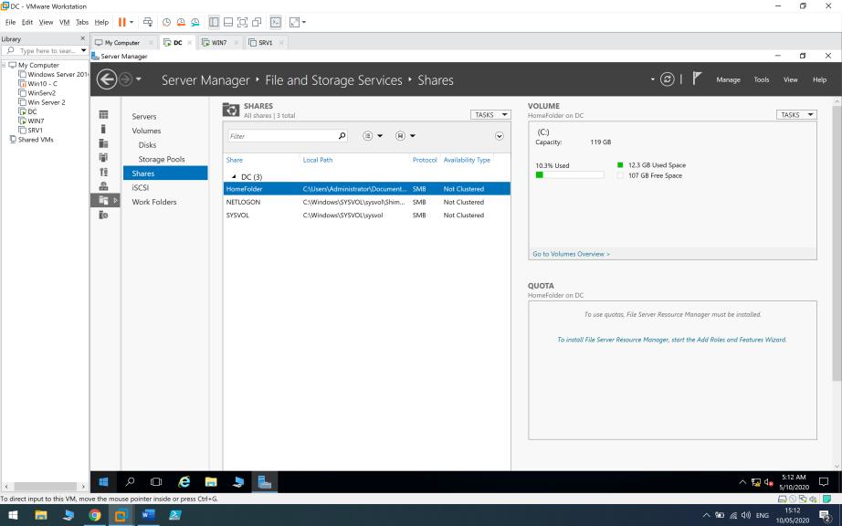

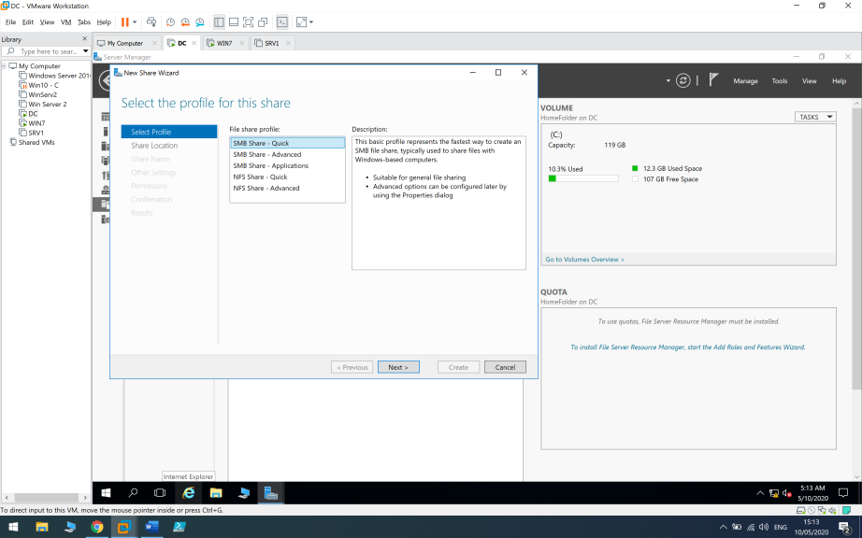

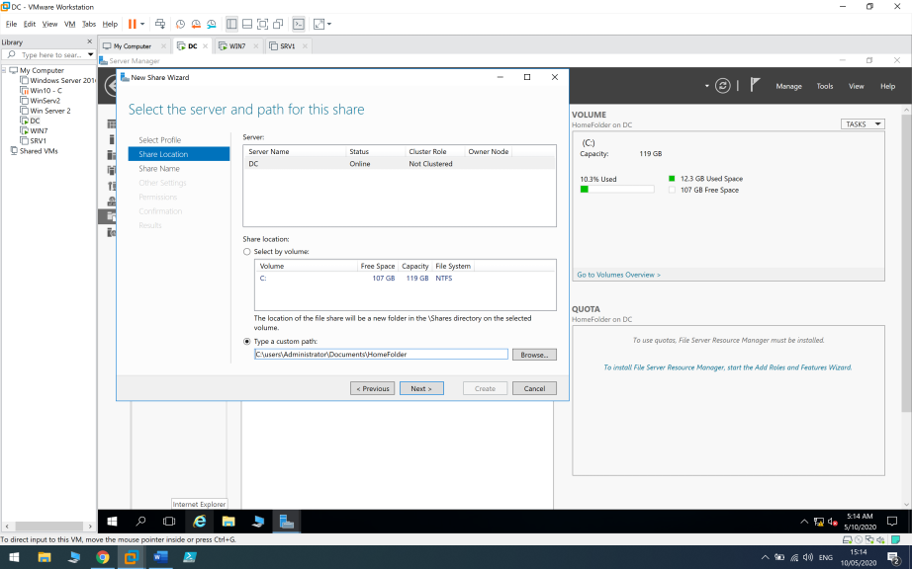

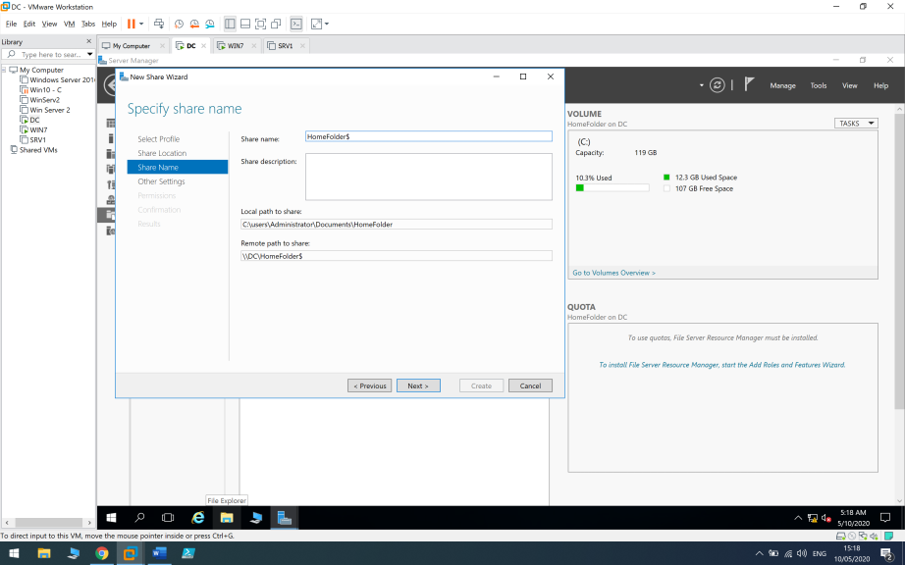

We need to tick “Enable access-based enumeration” so we can set permissions to users in order to access the folder.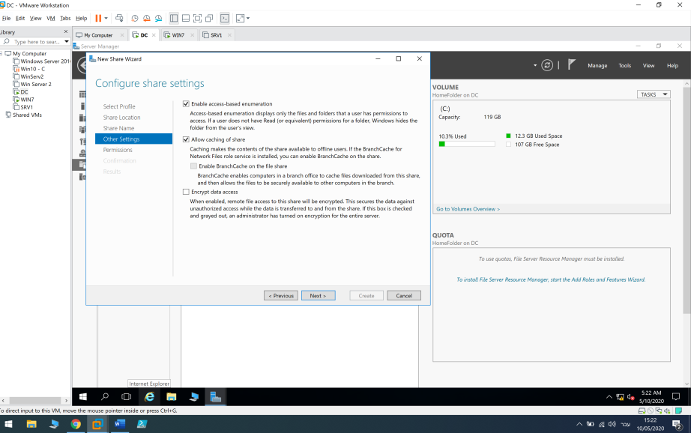

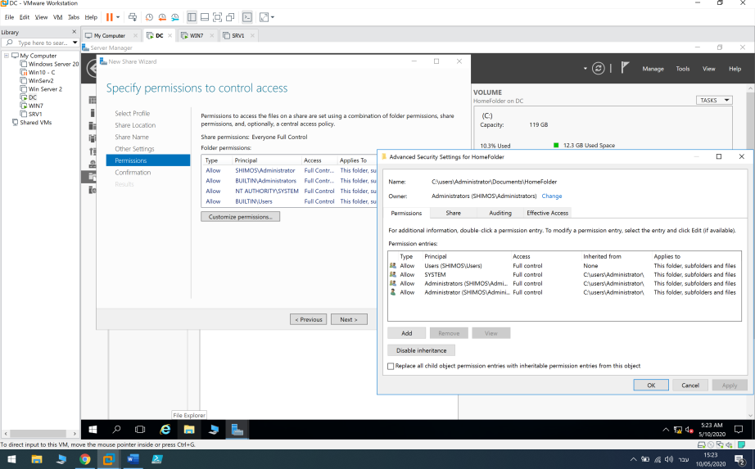

Here I converted the inheritance permissions to be explicit permissions on this folder , so the permissions won’t inheritate to other users \ folders .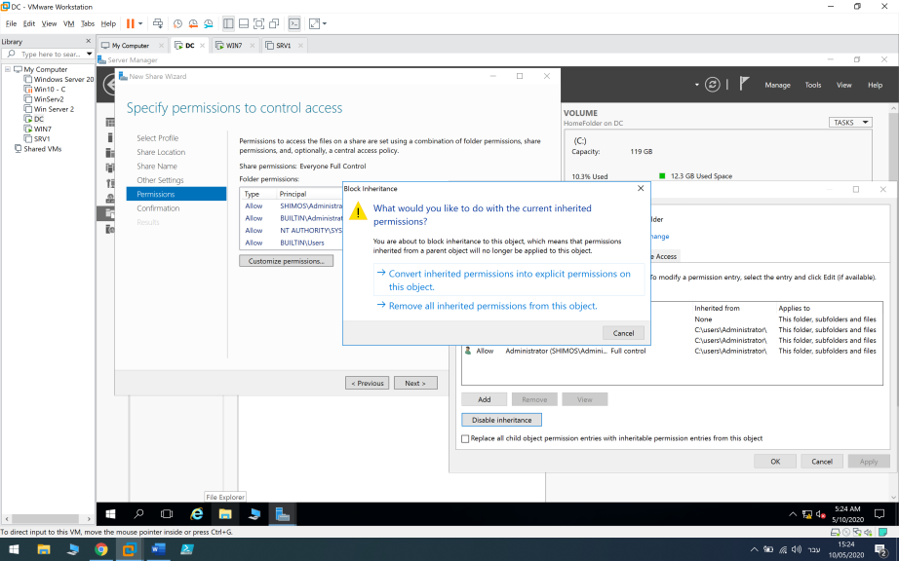

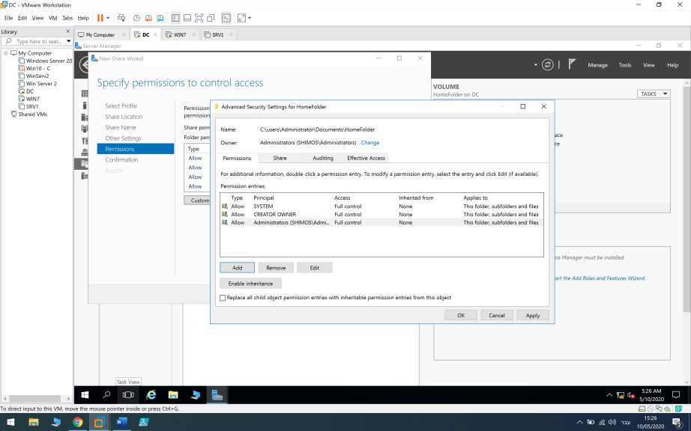

I added my user groups “Sales” and “SysAdmin” and gave them permissions to this folder only.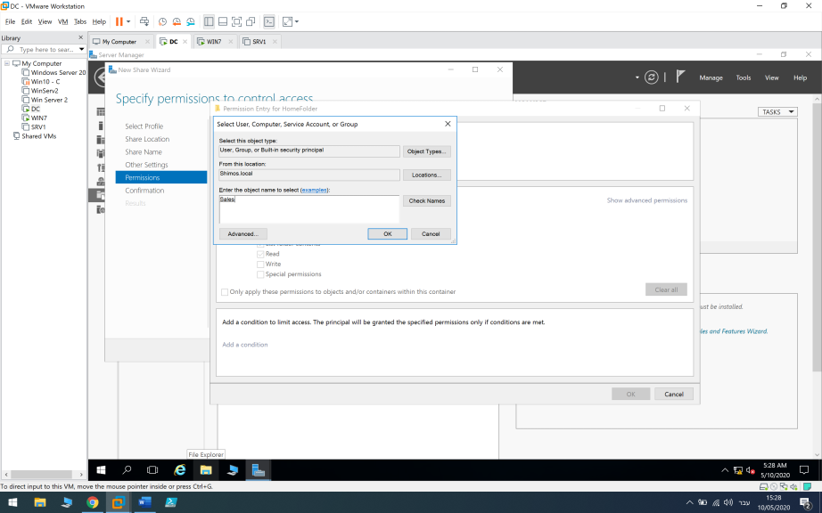

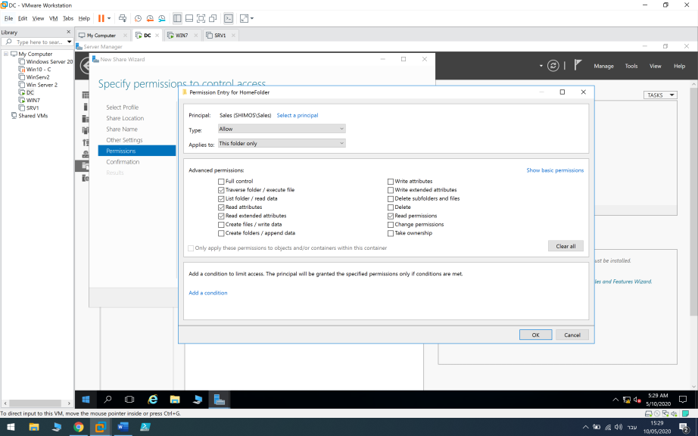

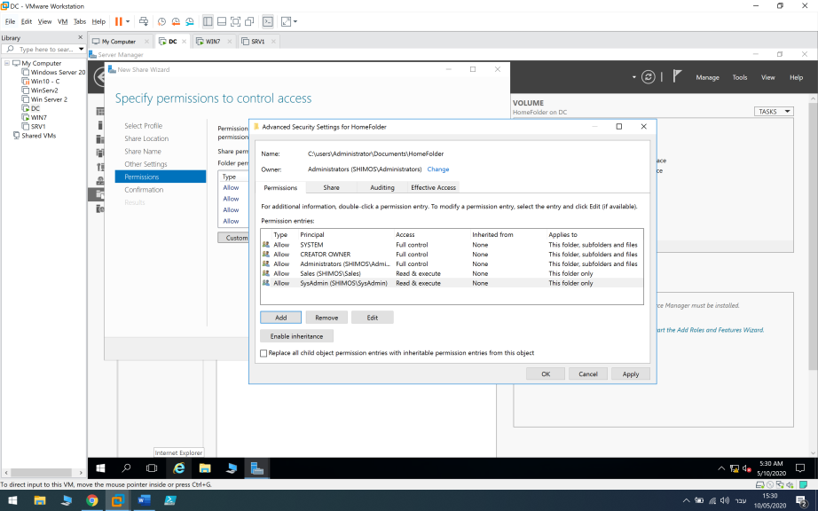

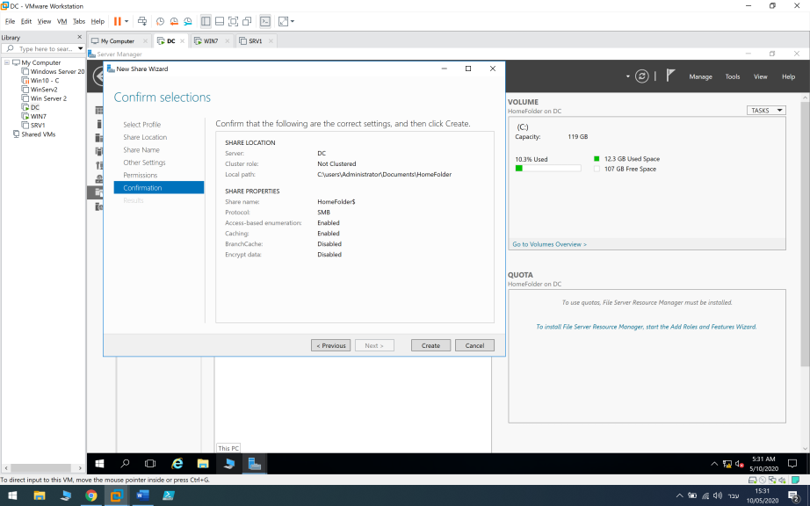

So now that I created the home folder for the users , I need to allocate the home folders for the users.

So we need to to go Tools > Active Directory Users and Computers > Mark User1 and User2 under “Sales” group > Right click > Properties > Profile > Tick “Home Folder” and allocate “H:” with the home folder path ( \\dc\homefolder$\$username% ) #username# means that the folder name will be named after the user name.

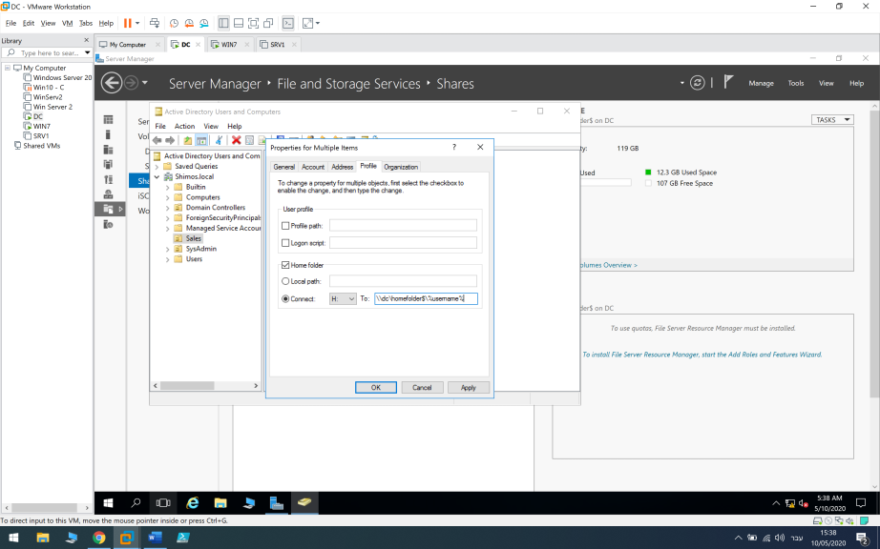

Now I will log in to User1 , WIN+R and write the path \\dc\homefolder$ and as we can see user1 can only see his folder.

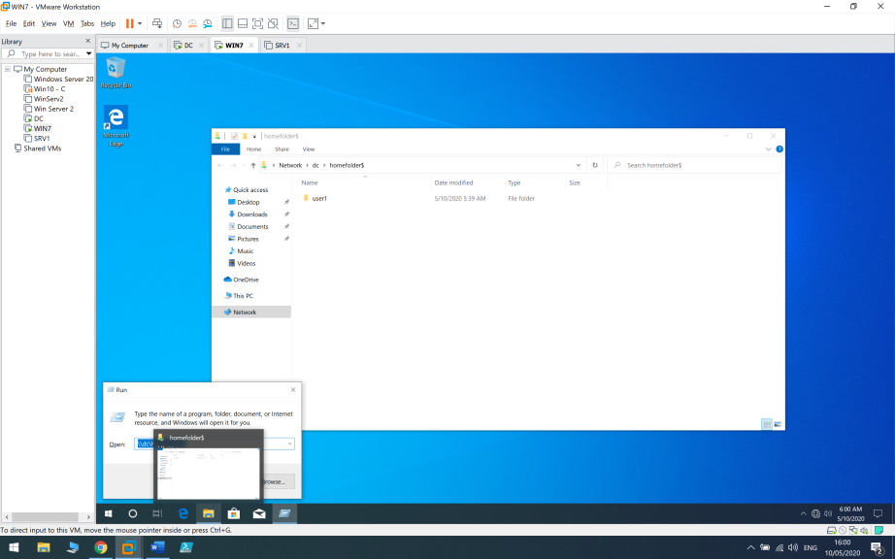

Also , if we try to access other user folder it will prompt a message that says we don’t have the permissions to enter.

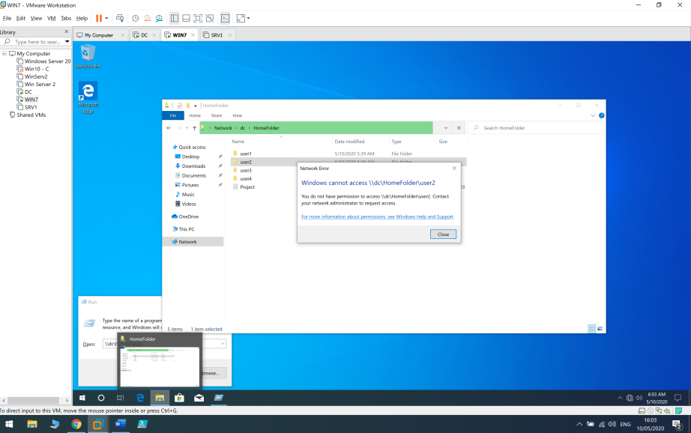

## 7.2 Shared Folder

Now on my DC I will share another folder “DATA” with “Project.txt” file”

On permission tab I will allow “Sysadmin” group to modify and “Sales” to read & execute.

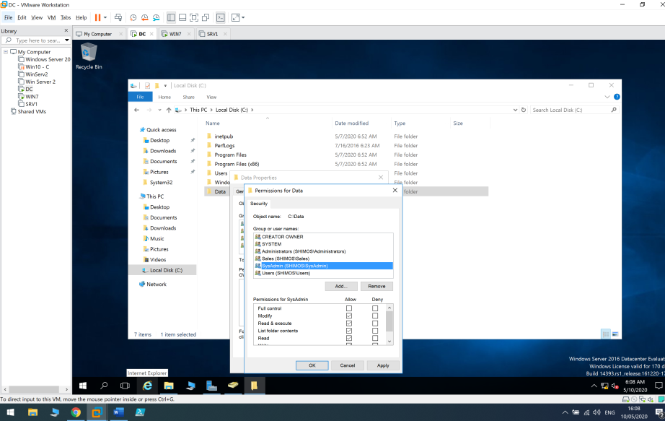

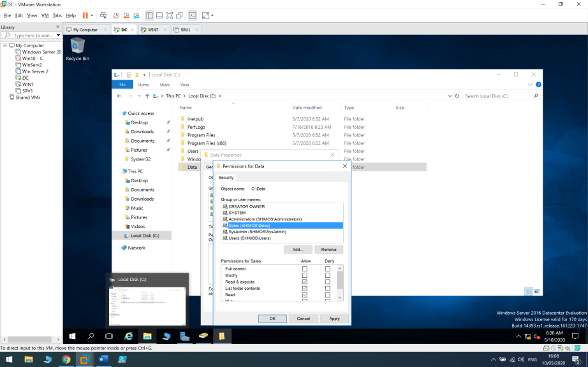

Then I will log in to USER3 in “SysAdmin” group and try to change the name of the file (Modify).

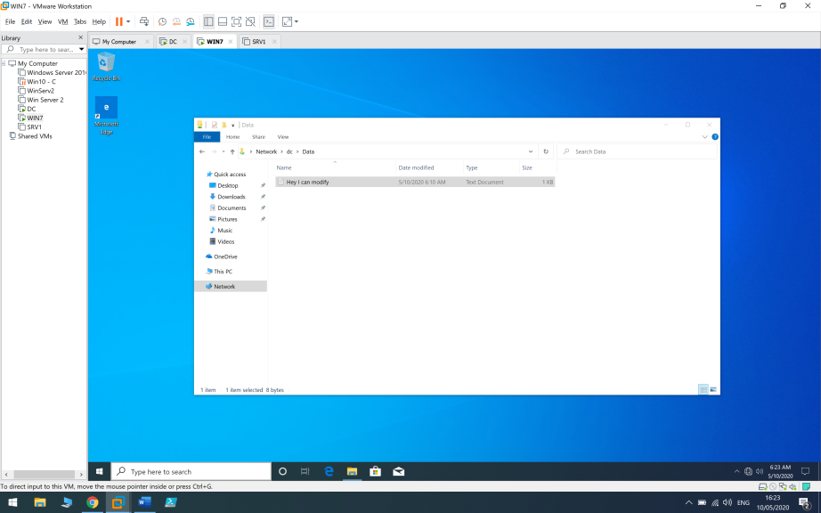

And on USER2 in “Sales” group I will try – and fail because I don’t have the permission to modify.

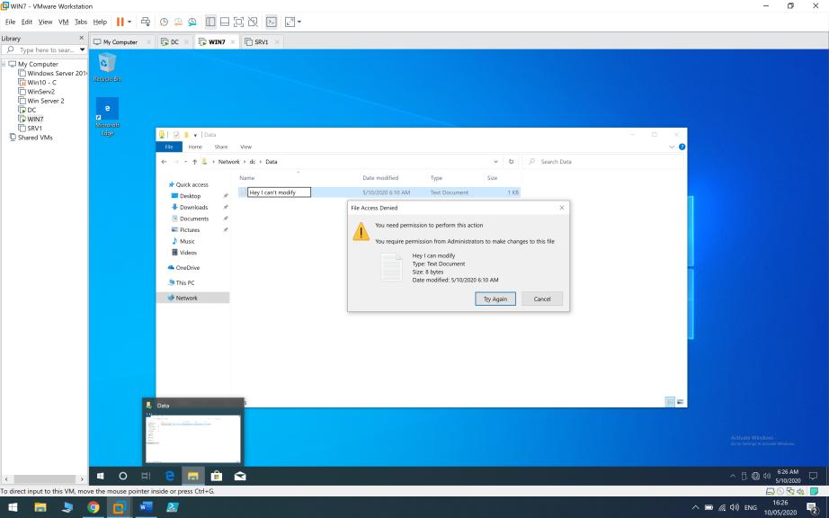

### 7.3 Map Drive

Now I will map “Data” folder to the whole network as a drive so it will have easy accessabillity to the users.

I go to “This PC” and click Computer in the upper taskbar and then “map network drive”.

I will give it our DATA folder path - \\dc\Data and will tick “Reconnect at sign-in”.

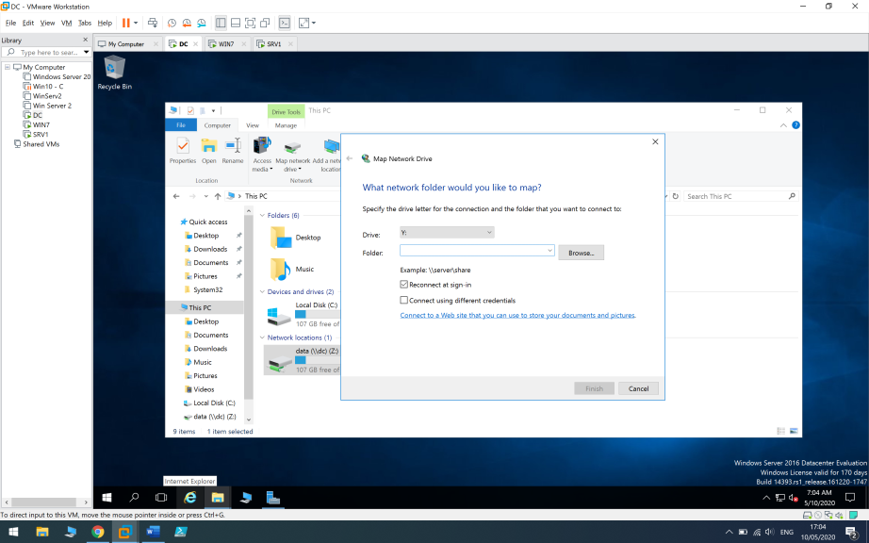

Now I can access the shared folder easily through This PC everytime.

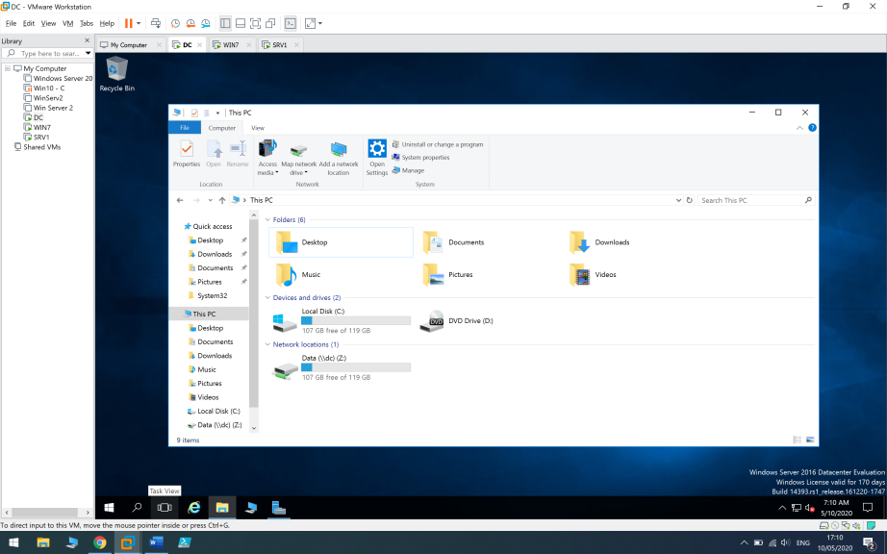

After mapping the shared folder as drive on USER1 at WIN7 client I went to check that the permissions remained the same and I still can’t modify It as USER1.

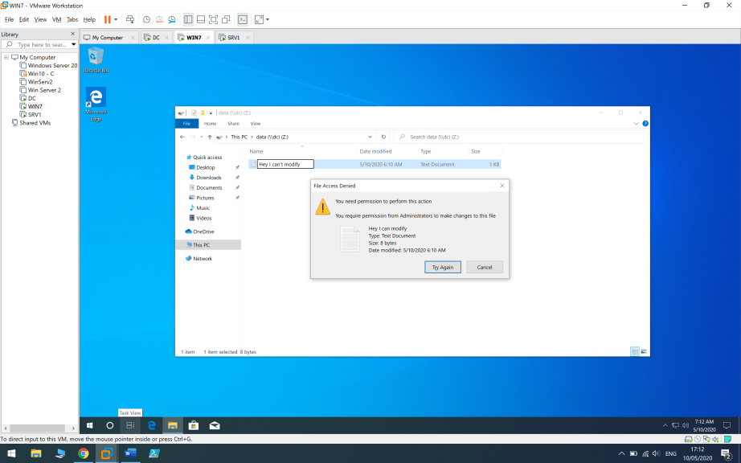

#### 7.4 Map drive using group policy

You can also share drive using group policy – Server manager > Tools > Group Policy Management > Right click on Shimos.local > Create a GPO in this domain and link it here.

I created a group policy “Map Drive” > Right Click > Edit > User Configuration > Preferences > Windows Settings > Drive Maps > Right Click > New > Mapped Drive.

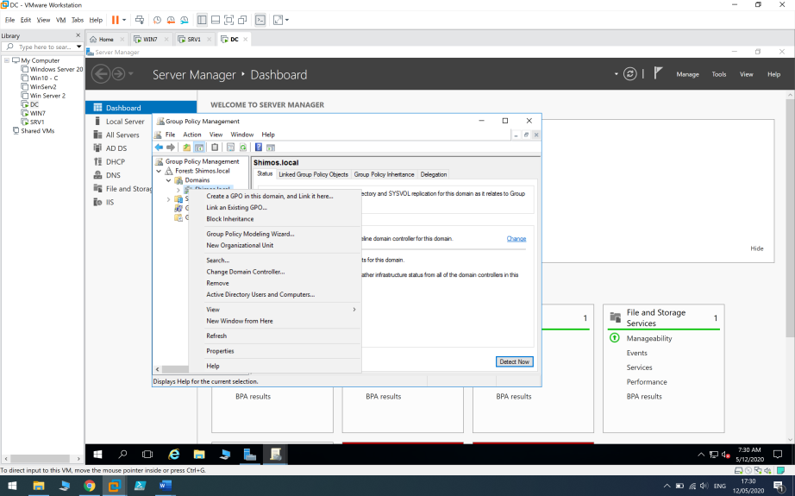

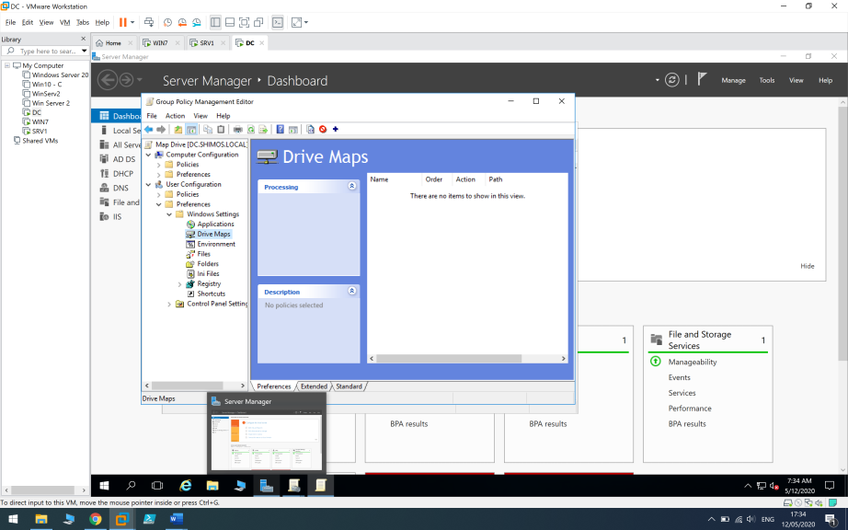

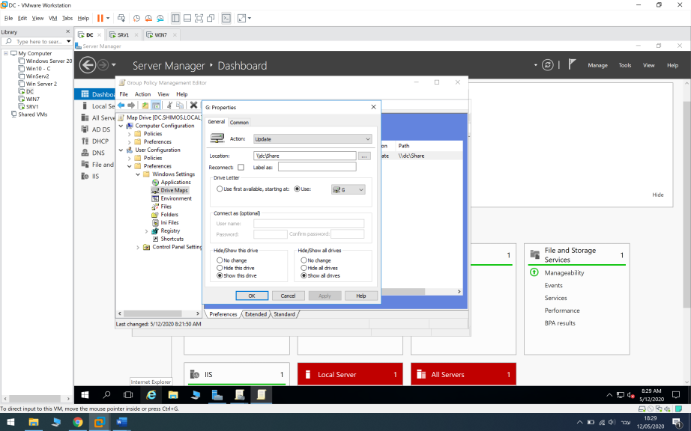

After creating the group policy , I will run the gpupdate /force command on cmd on my client (Restart is also an option) to see the changes and the drive we mapped.

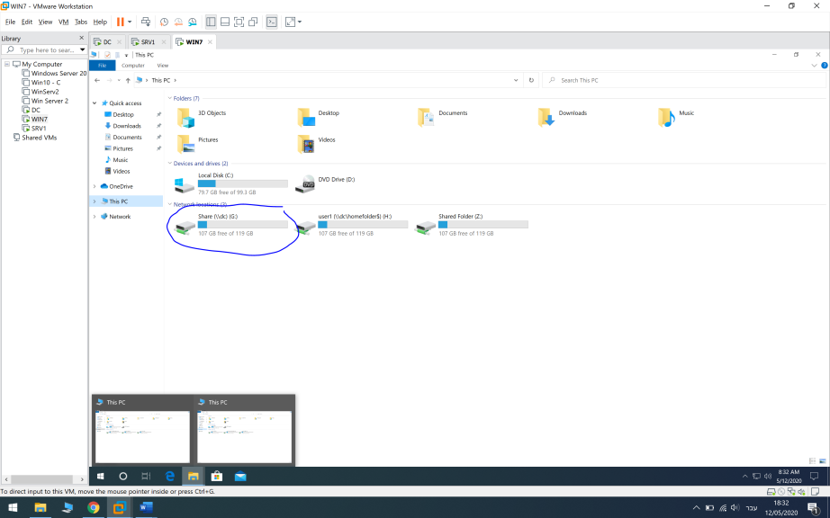

Now I only need to make sure the permissions remained the same as before (Sales read&execute and Sysadmin modify).

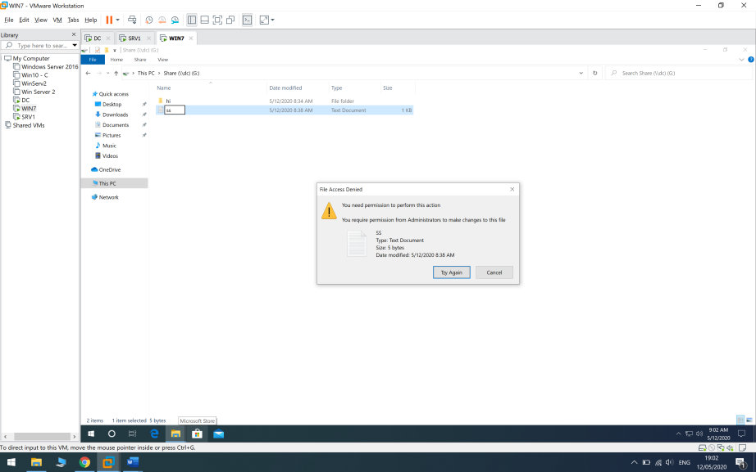

# 8.1 Remote Desktop Protocol

Normally I will make sure the remote desktop connection is allowed on This PC > Properties > Remote Settings > Allow Remote Connections To Computer or by creating a group policy –

**First of all I will add port 3389 – create new group policy , name it “Allow_RDP” > Edit > Computer Configuration -> Windows Settings -> Security Settings -> Windows Firewall with Advanced Security -> Windows Firewall with Advanced Security -> Inbound Rules and Create a New Rule.**

**Port > Specific Port – 3389 > Allow .**

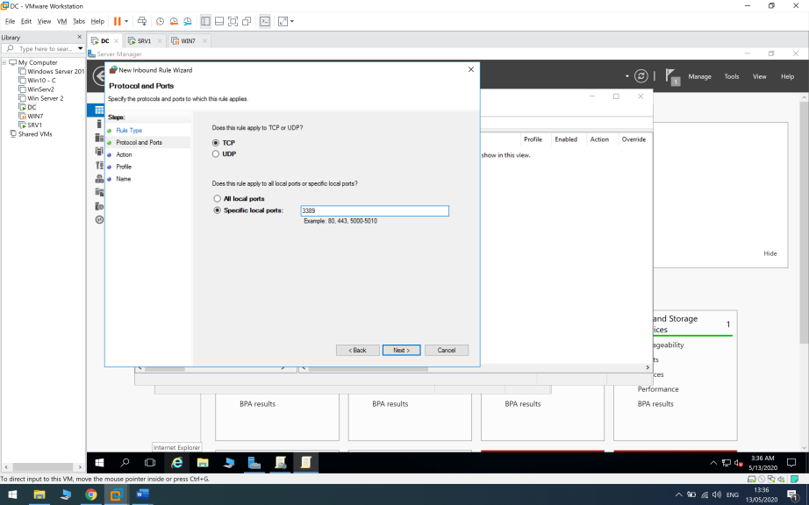

**Now I will enable remote desktop service -**

**Computer Configuration -> Policies -> Administrative Templates -> Windows Components -> Remote Desktop Services -> Remote Desktop Session Host -> Connections >** Allow users to connect remotely by using remote desktop service > Enabled.

(When installing Remote Desktop Service the settings is allowed automatically on DC).

I will go to server manager > Manage > Add Roles And Features > Remote Desktop Services Installation > Standart Deployment > Session-Based Desktop Deployment > Next > DC.Shimos.Local on Connection Broker , Web Access and Session Host Server.

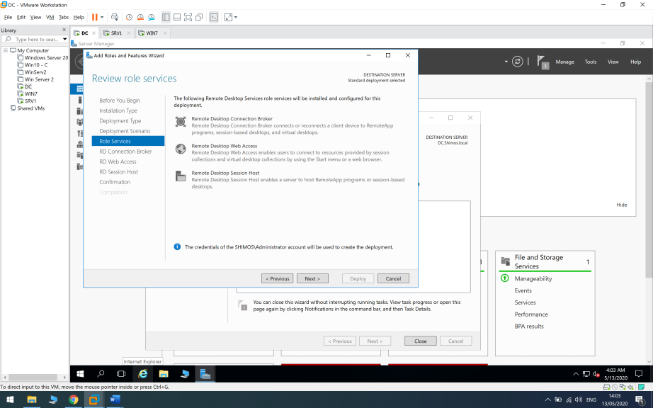

After the installation has completed I made sure “Allow Remote Connections On This Computer” is enabled and I also used “netstat -ano | findstr 3389” command on cmd.

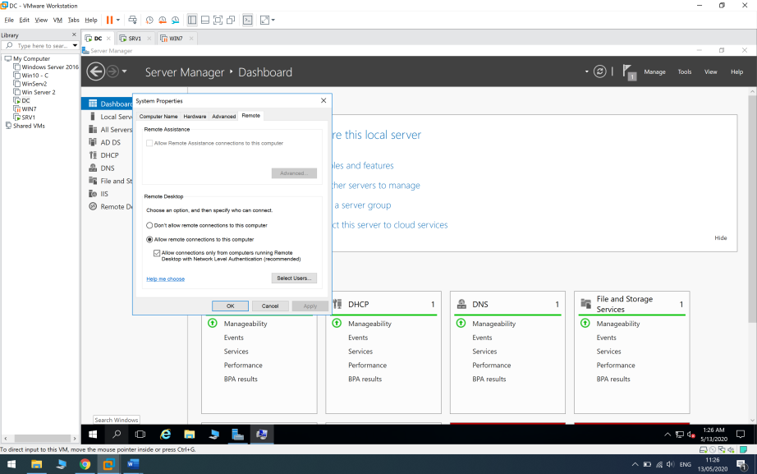

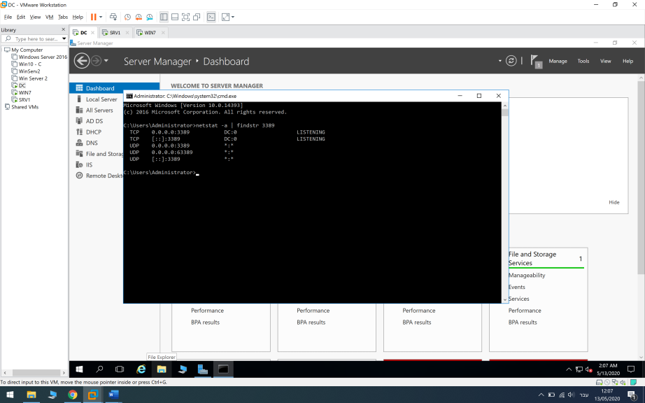

## 8.2 Remote Control DC

By default every administrator on the domain can use remote desktop service on every computer , but now I will allow Sysadmin group (User3 User4) to remotely connect to DC.

Now ill log in to User3 and write MSTSC on RUN line , write 172.31.0.20 > Give the necessary credentials and connect.

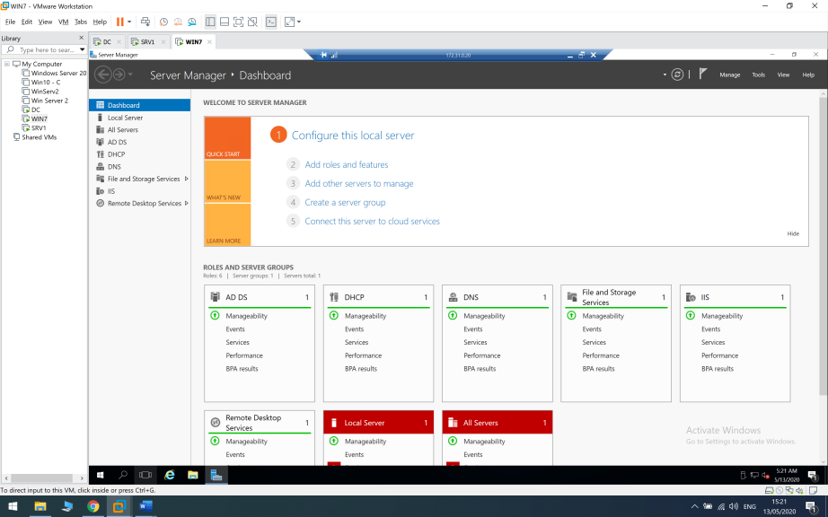

### 8.3 Remote Control DC using SSH

First I will download OpenSSH on DC and Putty on WIN7 client.

On DC I will go to System Settings > Advanced > Enviromental Variables > System Variables PATH > Edit > New > OpenSSH Location.

Afterwards I created new Inbound Rule on Windows Defender Firewall with Advanced Security and enabled port 22.

Then I ran Powershell as administrator and installed SSH –

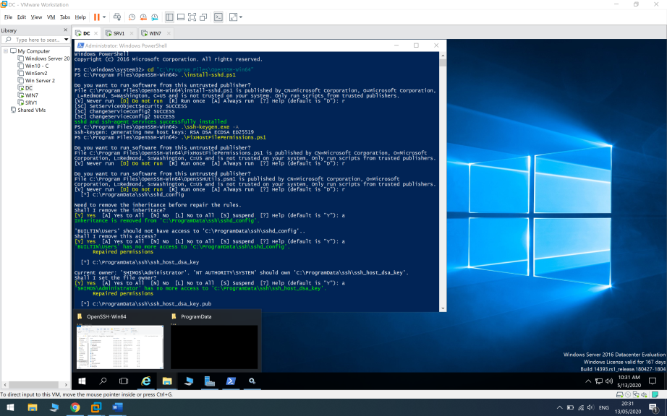

Then I went to enable the OpenSSH service on Server Manager > Tools > Services > OpenSSH SSH Server > Enabled and set to Automatic , OpenSSH Authentication Agent > Enabled and set to Automatic.

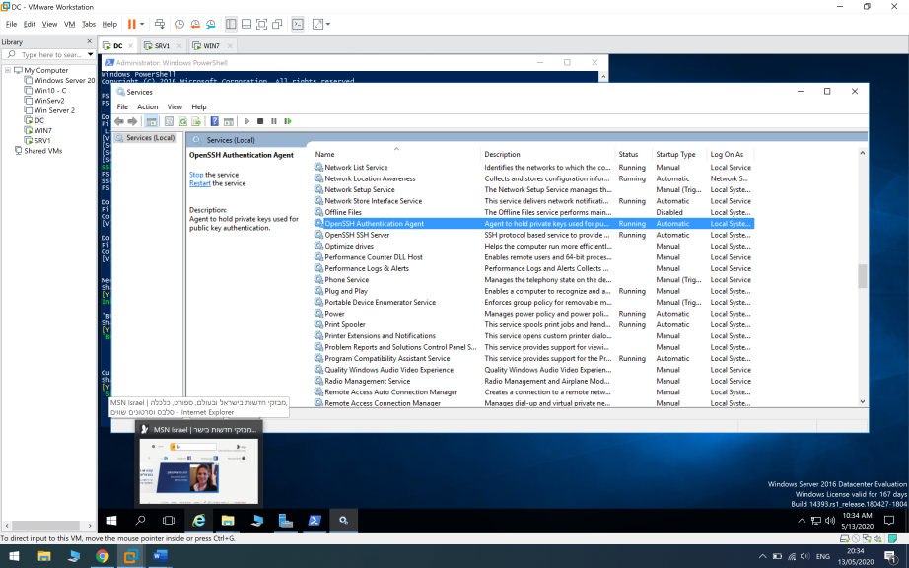

Now I logged in to User4 on my WIN7 client , ran Putty and typed 172.31.0.20 on the IP box > Open.

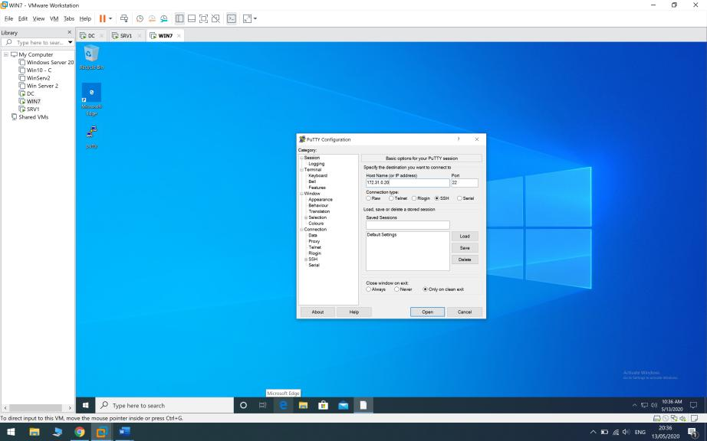

Give the necessary credentials – User4 Pa$$w0rd and that’s it , I am remotely controlling DC with putty using SSH.

For example , I changed directory to get to DC’s desktop and created a folder named “HiUriel”.

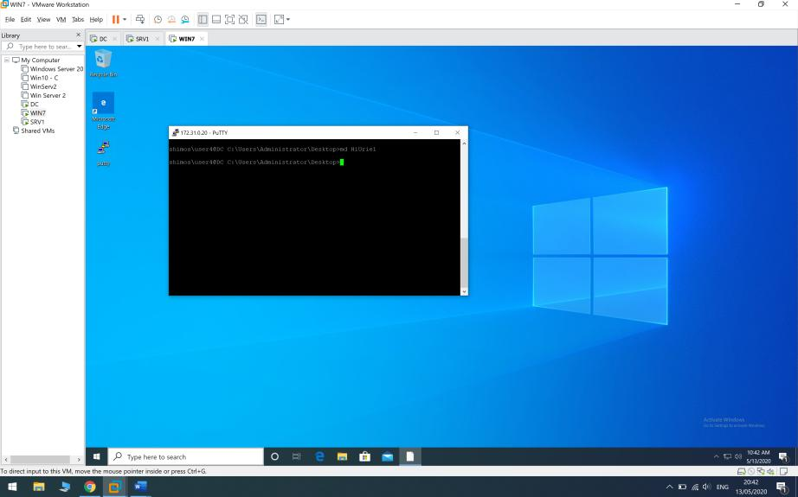

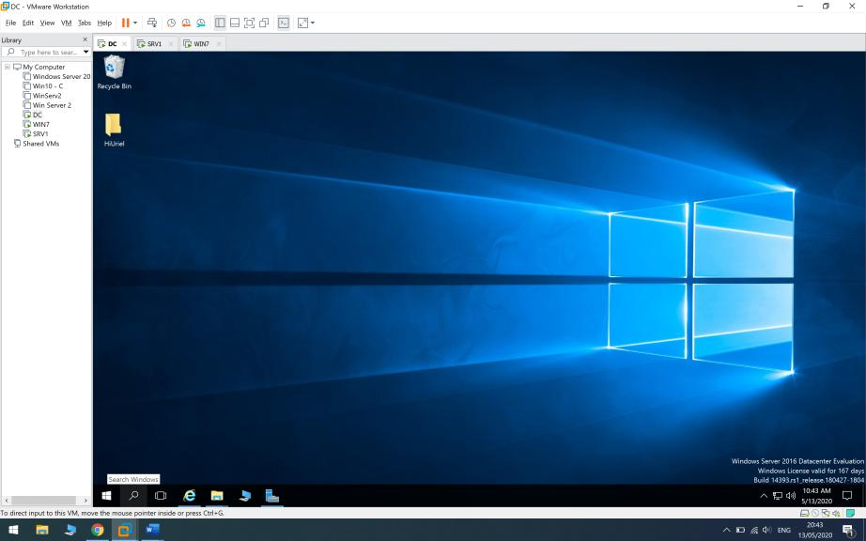

# 9.1 Hardening Clients

I will create a new group policy that will prohibit access to control panel and prevent access to the command prompt for users who are not on Sysadmin.

In the group policy manager editor we will navigate to User Configuration > Policies > Administrative Templates > Control Panel > Prohibit access to control panel and pc settings.

I will enable the setting.

Afterwards I will navigate to User Configuration > Policies > Administrative Templates > System > Prevent access to the command prompt.

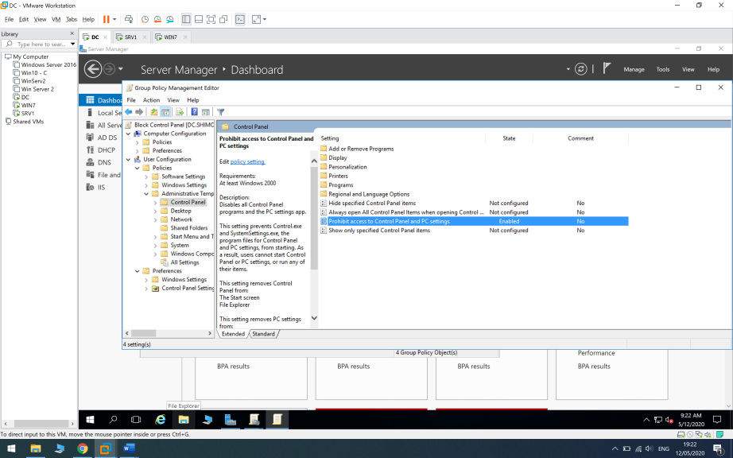

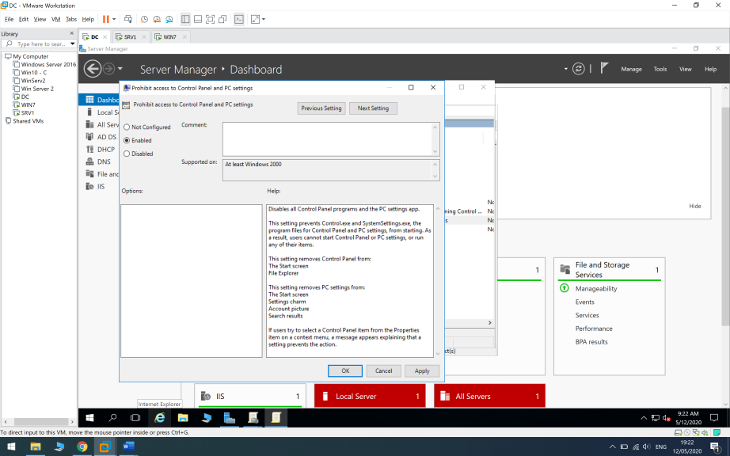

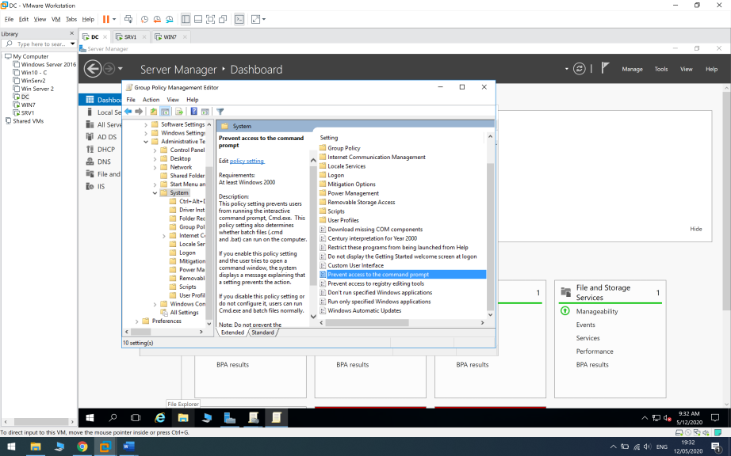

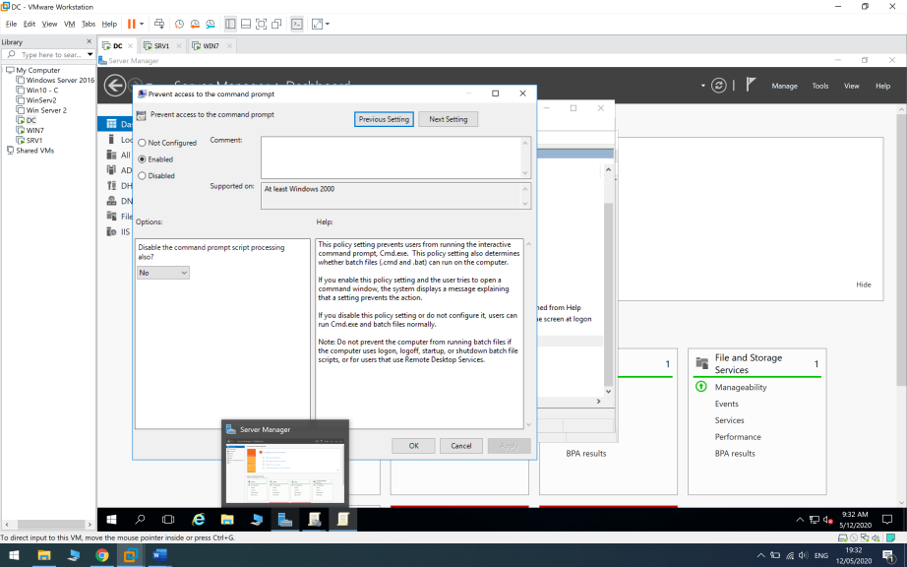

I will put the “Block CMD + CP” group policy under Sales OU.

Now when trying to get into control panel with User1 (Sales) I will get restriction error.

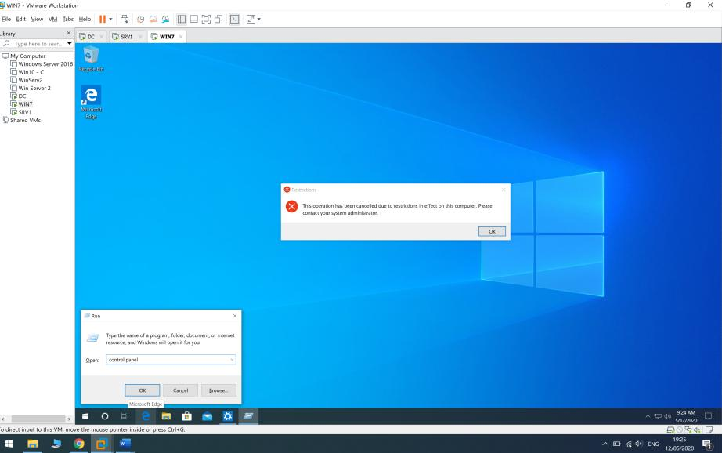

And when trying to run CMD we will get an error inside the command prompt itself “The command prompt has been disabled by your administrator”.

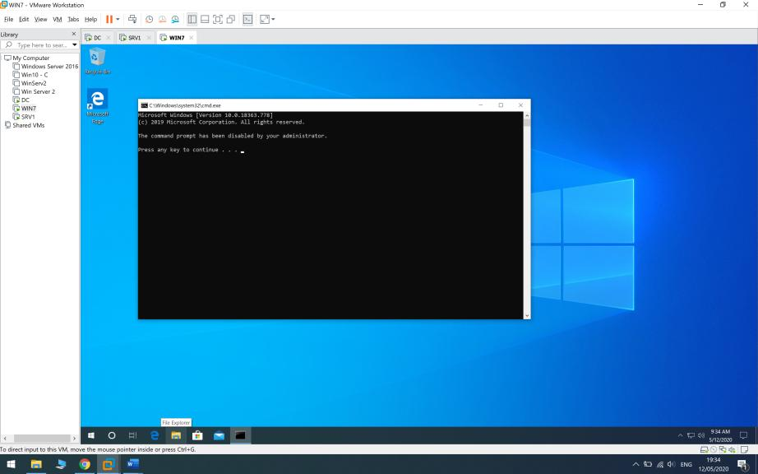

## 9.2 Block Disk-On-Key

I will create additional OU called “USB_Block” that will contain every domain PC in order to give this OU a group policy which will prevent them from using disk-on-key.

Under the OU I will create a group and add every PC in the domain.

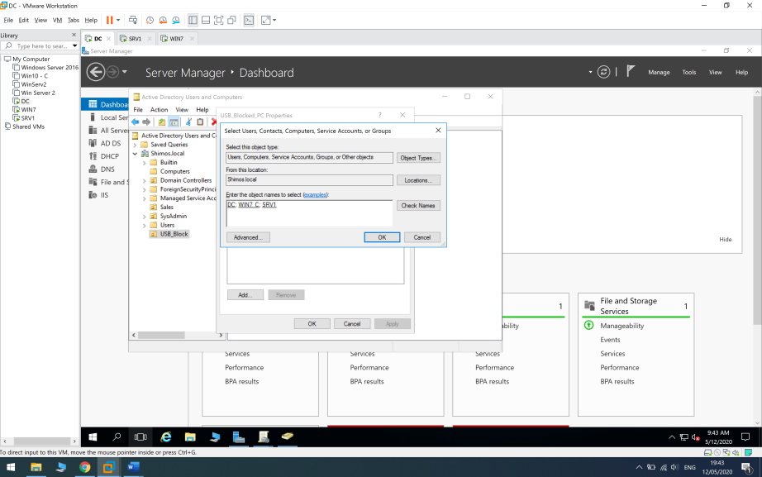

I create “Block_USB” group policy > Edit > Navigate to Computer Configuration > Policies > Administrative Templates > System > Removeable Storage Access > All Removeable Storage Classes:Deny All Access > Enabled.

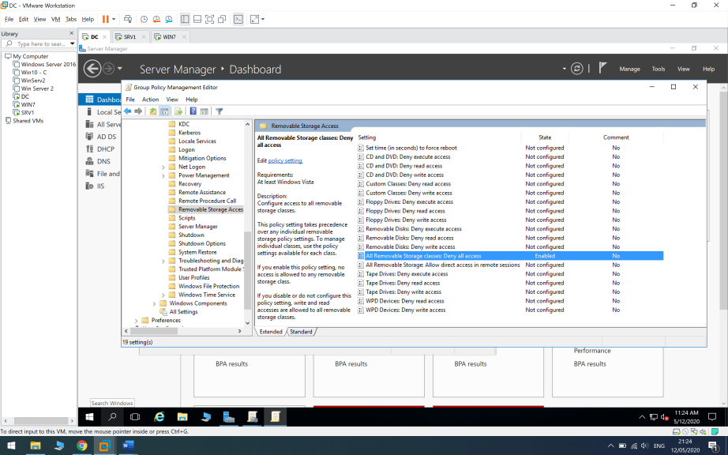

I will put the group policy under “Block_USB” OU that contains every PC in the domain.

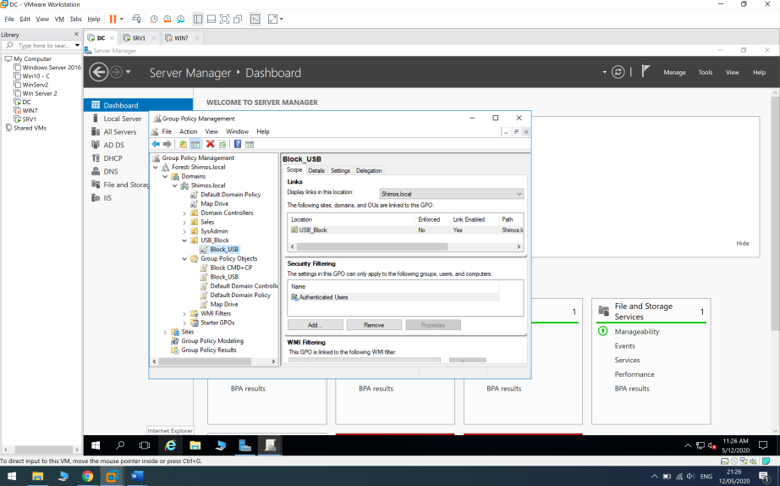

# 10.Snapshots Taken

I took several snapshots during the project , mostly after a big service installation.

Every snapshot taken was taken when the virtual machine was shutted down.

DC- After promoting to Domain Controller , Creating OU’s and Groups , Creating DHCP Server and configuring it and after installing Remote Dekstop Service.

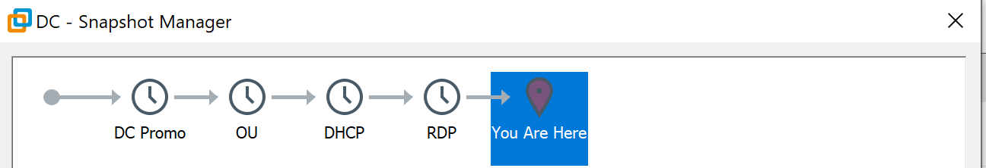

Win7- After joining the domain.

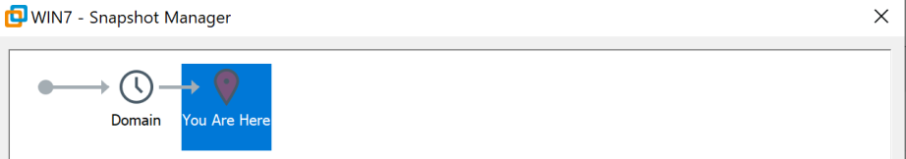

SRV1- After joining the domain and after installing Remote Access Role.

